

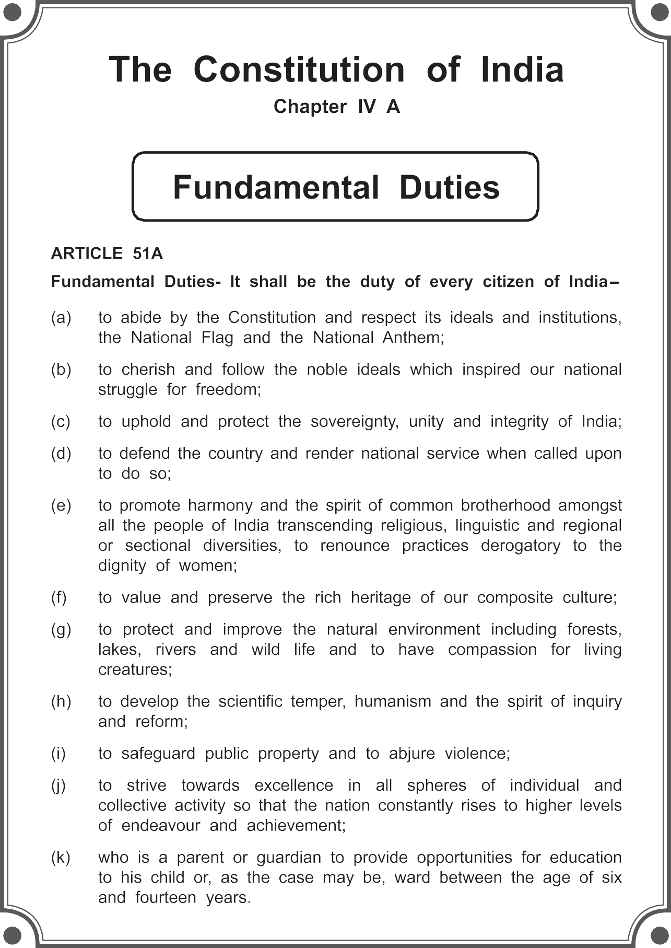

The Coordination Committee formed by GR No. Abhyas - 2116/(Pra.Kra.43/16) SD - 4 Dated 25.4.2016 has given approval to prescribe this textbook in its meeting held on 29.12.2017



from the Academic Year 2018-19.

ENGLISH

BALBHARATI

**STANDARD EIGHT**

## Maharashtra State Bureau of Textbook Production and Curriculum Research, Pune.

The digital textbook can be obtained through DIKSHA App on a smartphone by using the Q. R. Code given on title page of the textbook and useful audio-visual teaching-learning material of the relevant lesson will be available through the

Q. R. Code given in each lesson of this textbook.

**First Edition : 2018**

**© Maharashtra State Bureau of Textbook Production and Curriculum Research, Pune - 411 004.**

**Fourth Reprint : 2022**

The Maharashtra State Bureau of Textbook Production and Curriculum Research reserves all rights relating to the book. No part of this book should be reproduced without the written permission of the Director, Maharashtra State Bureau of Textbook Production and Curriculum Research, ‘Balbharati’, Senapati Bapat Marg, Pune 411004.

**English Language Committee :**

Dr Prabha Sampath, Chairman

Dr Manjushree Sardeshpande, Member Dr Rohit Kawale, Member

**Co-ordination :**

Santosh J. Pawar

Assistant Special Officer, English

**English Language Study Group :**

Dr Muktaja Mathkari, Member Dr Lalita Vartak, Member

Dr Shruti Chaudhary, Member Shri. Shridhar Nagargoje, Member Shri. Nilesh Kedare, Member

Shri. Santosh Pawar, Member-Secretary

**Cover :** Shri. Vivekanand Patil

**Illustrations :** Ashna Advani

Anupriya Joshi

Shri. Akhil Bhosale

Dr Jyotimani Rocque Smt. Manjusha Sagrolikar

Shri. Nilkantheshwar Patil Shri. Pundalik Kaviraj Smt. Renu Dhotre

Smt. Saraswathi Suram Shri. Sharad Pandhare Smt. Smita Pore

Shri. Amol Kamble Shri. Anil Petkar Shri. Ashok Gaikwad Shri. Mohan Bapat

Shri. Balkrishna Shinde

Shri. Bhuvnesh Kumbhar Dr Gajendra Mugale

Dr Juee Kulkarni

Shri. Mahesh Dudhankar Shri. Nadeem Khan

Shri. Rajiv Sangpal Shri. Raju Korde Shri. Rakesh Jadhav

Shri. Santosh Gaikwad

**Invitee Expert :**

Smt. Samannaz Irani

**Production :** Sachchitanand Aphale Chief Production Officer



Sachin Mehta Production Officer

Nitin Wani Assistant Production Officer

**Paper :**

70 GSM Creamwove

**Typesetting :**

DTP Section (Languages) Textbook Bureau, Pune.

**Printer :**

M/S. ELEGANT OFFSET PRINTERS PVT. LTD., KOLHAPUR

**Print Order No. :**

N/PB/2022-23/25,000

**Publisher :**

Vivek Uttam Gosavi **Controller** Maharashtra State Textbook Bureau, Prabhadevi,

Mumbai - 400 025.

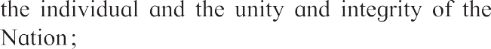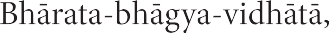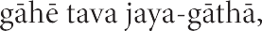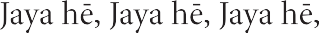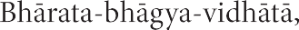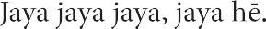

**Preface**

Dear Students,

A most hearty welcome to Std VIII. We are happy to place this textbook ‘**English Balbharati**’ in your hands.

English has been a part of your studies since Std I. So far, you have learnt to use English for communication in most situations. You have enjoyed some interesting stories, passages and poetry in the previous textbooks. You have completed many projects. You have also read the literary works of many well-known writers. Now that you are in Std VIII, you will do all this and also learn to use English with a better understanding of the language and the way it is used.

English is not just a subject in your curriculum. It is the medium through which you learn all other subjects. A good command over the language will make it easier for you to study other subjects too. English is a world language used internationally for communication. Our main aim is to help you use English with confidence. We want you to be able to ask questions, gain knowledge and new skills, be creative and to spend your free time deriving joy from appreciation of good literary pieces. That is why, we want you to take part in all the activities and exercises in the ‘Warming up’ and ‘English Workshop’ sections without feeling diffident. Talk to your teacher freely about the problems and difficulties you face while studying this textbook. Many of the activities are designed to show you ways of thinking and self-learning. The more you use them, the better you will grasp, learn and achieve.

Useful audio - video teaching - learning material given in each relevant lesson will be available through the Q. R. Code and through the medium of App for additional information. It will be definitely useful for your study.

We will be happy if you share your feelings about the contents of this book with us. We hope you enjoy studying it throughout the year.

Wish you all the best in your studies !

**Pune**



**Date :** 18 April 2018

Akshayya Trutiya Indian Solar Year : Chaitra 28, 1940

**(Dr Sunil Magar) Director**

Maharashtra State Bureau of Textbook Production and Curriculum Research, Pune.

**English Balbharati Standard VIII - Learning Outcomes**

* understand the context for various types of writing: messages, notice, letter, report, biography,

**Suggested Pedagogical Processes**

**The learner may be provided opportunities in**

**pairs / groups / individually and encouraged to–**

* participate in classroom activities / school programmes such as Morning Assembly / extempore / debate etc. by being exposed to input- rich environment.
* speak about objects / events in the class / school environment and outside surroundings.
* participate in grammar games and kinaesthetic activities for language learning.
* use English news (newspaper, TV, Radio) as a resource to develop his/her listening and reading comprehension, note-taking, summarizing etc.
* watch / listen to English movies, serials, educational channels with sub-titles, audio-video / multi-media materials, for understanding and comprehension.
* interview people from various professions such as doctors, writers, actors, teachers, cobblers, newspaper boy, household helps, rickshaw pullers

/ drivers and so on.

* use formulaic expressions / instructions such as ‘Could I give you…’ ‘Shall we have a cup of tea?’ to develop communication skills
* participate in individual activities such as introducing personalities / guests during school programmes.
* learn vocabulary associated with various professions and use them in different situations.
* read stories / plays (from different books / newspapers in education (NIE) / children’s section in magazines in English) and narrate them.
* locate main idea, sequence of events and co-relate ideas, themes and issues in a variety of texts in English and other languages.
* use various sources from English and other languages to facilitate comprehension, co-relation and critical understanding of issues.
* interpret quotations, sayings and proverbs
* interpret photographs / sketches, tables, charts, diagrams and maps and incorporate in writing.
* think critically, compare and contrast characters / events / ideas / themes and relate them to life and try to give opinions about issues.
* refer sources such as dictionary, thesaurus and encyclopedia for meaning in context and understanding texts.
* use grammar in context such as active and passive voice, reported speech, tenses, parts of speech, etc.
* notice punctuation marks in a variety of texts and appropriately use in editing his / her own writing.

travelogue, diary entry etc.

* + take dictation of a passage with specific attention to words pronounced, punctuation and spelling.
  + attempt various types of writing: notice, letter, report, etc as well as personal / biographical experiences and extrapolative writings.
  + use ICT (Net, mobile, website, Youtube, TED talks etc) to browse for information, for projects / PPT discussion, debate, class seminar etc.
  + attempt creative writing, like stories, poems, dialogues, skits, dialogues from a story and story from dialogues.
  + visit a language laboratory.
  + read / write a book review.

**Learning Outcomes**

**The learner–**

* + 1. Listens attentively to a variety of programmes.
    2. Notes specific details, facts, information from a speech, story, conversation, etc.
    3. Predicts the next part of a story, argument, etc.
    4. Retells the outline of a conversation, informative speech or debate.
    5. Respects variation in language use.
    6. Responds to instructions and announcements in school and public places such as railway station, bus-stand, market, airport, cinema hall, malls and acts accordingly.
    7. Participates in class / group discussion.
    8. Participates in different events such as role play, poetry recitation, skit, drama, debate, speech, elocution, quiz etc. organized by school and other such organizations.
    9. Describes things, people, situations, emotions, etc.
    10. Demonstrates a process / activity clearly.
    11. Work out a problem orally.
    12. Discusses / talks about the characters, situations, plots, themes, etc. of a literary piece.
    13. Presents one’s thoughts, arguments in a logical, organized manner.
    14. Uses persuative language to convince others.
    15. Endorse/oppose a particular point of view.
    16. Uses quotations, idioms, proverbs appropriately.
    17. Introduces guests in English, interviews people by asking questions based on the work they do.
    18. Engages in conversations in English with people from different professions using appropriate vocabulary.
    19. Writes emails, messages, notice, formal letters, descriptions / narratives, personal diary, report, biographical experiences etc.
    20. Understands the organization of graphic presentations and uses them appropriately.
    21. Remembers and recalls necessary

08.03.47

08.03.48

08.03.49

information (and the way it is organized) with the help of personal notes.

Revises (increasingly larger) chunks of information mentally.

Translates different types of informative texts from the mother tongue into English and from English into the mother tongue.

Translates literary pieces from the mother tongue into English and from English into the mother tongue.

* + 1. Uses digital dictionaries / standard dictionaries, thesaurus, encyclopedia available on the internet for reference.
    2. Prepares graphics, word-art, graphs, pictograms, etc. on the computer.
    3. Knows how to compile, edit and uses the information or details available on the internet and not just ‘copy-paste’ them.
    4. Takes care not to use copyright material without proper permission and / or acknowledgement.
    5. Prepares a presentation with the help of a computer.
    6. Participates in language games and activities for language learning.
    7. Speaks about events in the class / school environment and outside the surroundings.
    8. Understands the storyline in a narration / play, etc.
    9. Predicts the next part in a conversation / story /narration, etc.
    10. Understands the connection between the major and minor points in a piece of writing.
    11. Reads carefully to understand a new concept

/idea.

* + 1. Reads so as to compare / contrast bits of information.
    2. Understands the writer’s intention.
    3. Understands / empathises with other points of view.
    4. Understands and appreciates use of literary devices, figures of speech, etc.
    5. Verifies information using various sources / references.
    6. Learn new words, expressions and enriches his / her vocabulary through reading.
    7. Identifies verbosity, lack of organization, and other defects in written communication.
    8. Reads excerpts, dialogues, poems, commentaries of sports and games, news, debates on TV, radio and expresses opinions about them.
    9. Reads textual / non-textual materials in English.

**Language Study**

Be aware of the following concepts to understand how language is used.

**The Alphabet :**

* Phonetic symbols

**Parts of Speech :**

* Finite verbs and Infinitives, Gerund, Participles,Time, Tense and Aspects, Degrees of Comparison, Pronoun and its types

**Sentence Structure :**

* Phrase and Clause
* Coordination and Subordination (Simple, Compound and Complex Sentences)
* Transformation
* Negative Constructions
* Joining Sentences
* Reported Speech

**Vocabulary and Word building :**

* Minor processes of word - building
* Reduplicatives, Clipping,Blending, Acronym

**Punctuation :**

* Quotation marks, Apostrophe, Use of Capitals

**Speech :**

* Syllables, Stress, Intonation

**Figures of Speech :**

* Personification, Hyperbole, Apostrophe, Idioms
  + 1. Identifies details, characters, main idea and sequence of ideas and events while reading.
    2. Reads, compares, contrasts, thinks critically and relates ideas to life.
    3. Reads a variety of texts for pleasure. For example, adventure stories, science fiction, non-fiction articles, narratives, travelogues, biographies etc. (Extensive reading.)
    4. Fill forms correctly.
    5. Voices his / her doubts, problems, etc. clearly but politely in writing.
    6. Explains a concept / an idea in short.
    7. Compares and contrasts bits of information, etc.
    8. Attempts using different styles and techniques of writing and literary devices to make his / her writing more effective.
    9. Prepares a write up after seeking information in print, online, noticeboard, newspaper etc.
    10. Writes a coherent and meaningful paragraph through the process of drafting, revising, editing and finalizing.
    11. Writes short paragraphs coherently in English.

CONTENTS



* 1. **A Time to Believe**
  2. **Dick Whittington and his Cat**
  3. **The Pilgrim**
  4. **Revathi’s Musical Plants**

**1**

**5**

**12**

**16**



* 1. **Vocation**
  2. **Nature Created Man and Woman as Equals**
  3. **The Worm**
  4. **Three Visions for India**
  5. **The Happy Prince**

**26**

**30**

**36**

**39**

**45**



* 1. **The Plate of Gold**
  2. **The Kite Festival**
  3. **The Last Leaf**
  4. **Leisure**

**56**

**61**

**66**

**73**



* 1. **The Vet**
  2. **Revolutionary Steps in Surgery**
  3. **The Bees**
  4. **Ramanujan**
  5. **A Battle to Baffle**

**76**

**80**

**87**

**91**

**98**

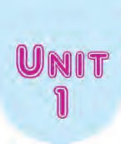

**1.1 A Time to Believe**

* + - 1. **Think, choose and fill up the labels with what a ‘sunrise’ symbolizes.**



(jewellery / art / hope / birth / anger / new opportunities / good manners / inspiration

/ new achievements / happiness / misery / bright moments / new aims / money / new surprises)

* + - 1. **An acrostic is a poem or a write-up in which the first letter of each line forms a word, when it is read vertically.**

For example, **F**aithful

**R**eliable **I**nspiring **E**ncouraging **N**oble **D**edicated

With your benchmate / group, complete the acrostic of BELIEVE and FAITH.

*(Please note that the words / phrases should be more or less related to the topic. You can use a* ***thesaurus****.)*

Be certain of F

E A

L I

I T

E H

V Generally a thesaurus is a reference book that lists words

E grouped together according to similarity of meaning. (Containing synonyms and sometimes antonyms)

# A Time to Believe

***What should one know and trust every day?***

**stardust :** having a magical quality

***What are the two supernatural references in the 2nd stanza?***

**nurturing :** providing nourishment, care and protection

**aging :** growing old

***What two qualities are needed to recover, after a shocking event?***

**pick up the pieces :** return to normal after a shock or disaster

**cherish :** hold something as very dear and of great value

**within reach :**

possible to achieve

‘‘To believe is to know that everyday is a new beginning.

Is to trust that miracles happen, and dreams really do come true.

To believe is to see angels dancing among the clouds.

To know the wonder of a **stardust** sky and the wisdom of the man in the moon.

To believe is to know the value of a **nurturing** heart,

The innocence of a child’s eyes and the beauty of an **aging** hand,

for it is through their teachings, we learn to love.

To believe is to find the strength and courage that lies within us,

When it is time to **pick up the pieces** and begin again.

To believe is to know we are never alone,

That life is a gift

and this is our time to **cherish** it.

To believe is to know

that wonderful surprises are just waiting to happen,

And all our hopes and dreams are **within reach**.

If only we believe.’’

*- B J Morbitzer*



***What kind of attitude does the poet advise everybody to have?***

2



1. **(A) Rearrange the letters to make meaningful words, occuring in the poem.**
   1. clearmis
   2. sowmid
   3. gearuoc
   4. rissupser
   5. tabyue
   6. madres
   7. laveu
   8. downre
2. **Write words from the poem that describe the following.**
   1. sky
   2. heart
   3. hand
   4. beginning
   5. surprises
3. **Say WHY. . . . .**
4.  the sky has a magical quality.
5.  even an aging hand has beauty.
6.  we should believe that we are strong and courageous.
7. **Make a list of any six things that the poet wants us to accept as true.**

(a)

(b)

(c)

(d)

(e)

(f)

1. **Find from the poem, positive qualities to fill up the web.**

**Positive Qualities**

1. **Read the lines below.**
2. ‘To believe is to see angels dancing among the clouds’.

The above line contain a human characteristic ‘dancing’ given to something

non - human, ‘angels’. The Figure of Speech used in the line is called ‘**Personification**’.

1. ‘To believe is to know that Everyday is a new beginning’.
2. To believe is to know life is a gift

Lines in poetry, such as the above, state a general truth and can be used as sayings or quotes etc. They contain the Figure of Speech called **Epigram**.

Epigram closely resembles a proverb.

* **Find from the poem three other examples of Epigram.**

(1)

(2)

(3)

1. **Divide the class into 5 groups. Each group can prepare a decorative chart / poster using an epigrammatic lines from the poem. You may use calligraphy / painting / or Paint programme on a computer. (With permission, put up these charts in your school.)**





4

# Dick Whittington and his Cat

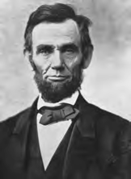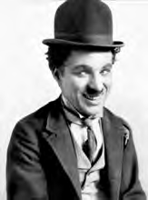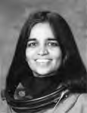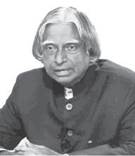



1. **Discuss the following in groups and write the answers.**
   1. Name the world famous personalities, who reached great heights despite of humble circumstances.
   2. Guess the types of hardships they must have faced in their childhood and youth.

(i) (ii)

(iii) (iv)

* 1. What strong qualities possessed by them, could have helped them achieve success and fame, all over?

(i) (ii)

(iii) (iv)

* 1. How do stories / biographies of such famous people help youngsters?

(i) (ii)

(iii) (iv)

1. **Syllable : A syllable is a unit of pronunciation that has one vowel sound and may or may not have consonant sounds before / after it.**

Examples of words having : **One syllable** : a, I, see, at, on, man, with, thread

**Two syllables** : mother, seated, giraffe, parrot, active, happy

**Three syllables** : happiness, wonderful, animal, surprising, adventure, ignorance.

**More than three syllables** : consequently, encouragement, responsibility, identifying, encyclopedia

**Write the names of any 5 of your classmates and list how many syllables each name has.**

5

# Dick Whittington and his Cat



***What innocent belief made Dick decide to go to London?***

**dismay :** great disappointment

**alley :** a narrow passage between or behind buildings

***What hardships did he face on arriving in London?***

*T*here was once a poor boy called Dick Whittington who lived in a small village in the south of England.

He had no proper home, for both his parents had died and he was unkindly treated by many of the villagers. One day, Dick overheard someone say that the streets of London were paved with gold and he decided that he would go there at once and pick his fortune up in gold pieces from the streets, for he thought people might treat him more kindly, if he were rich.

So young Dick set out to walk to London. He had not gone far when a man in a cart stopped and asked him if he was running away from home. “I have no home,” Dick answered. “I am on my way to London to find my fortune.”

“I’m going to London myself,” said the carter. “Jump up here beside me and we will journey together.”

They arrived in London just before nightfall and the carter left Dick and made his way to an inn. Poor Dick stood alone and looked around him in **dismay**. Where was all that fine gold? All he could see were dirty streets and lots of unfriendly people. He had nowhere to sleep and in the end he spent the night in the corner of an **alley** where he hoped he would come to no harm.

The next morning Dick woke up cold, miserable and very hungry. He wandered around begging for food, but again and again people shouted at him, “Go away you lazy fellow! Be off with you,” and aimed angry blows at his head. At last he collapsed in the street and lay there, too weak to look further for food.

By chance, Dick had fallen in front of a house belonging to a rich merchant called Mr Fitzwarren. The cook was trying to drive Dick away, when Mr Fitzwarren returned home from inspecting his ships. He stopped and said to Dick, “Why don’t you work if you need food ?”

“I would work,’’ said Dick, “but I know nobody who will give me anything to do.”

“Take him into the kitchen,” Mr Fitzwarren ordered the cook. “Feed him first and then find some work for him.”

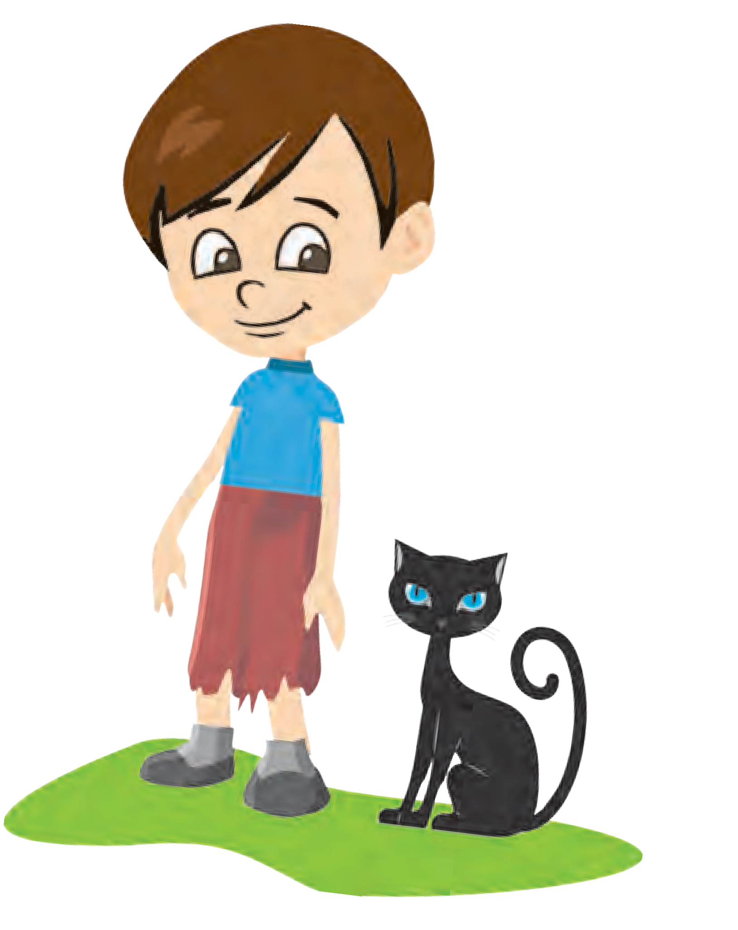

So Dick was given a home and a living. He had a small corner of the **attic** to sleep in and his job was to help the cook with all the pots and pans in the kitchen. Dick’s life should have been much better than before, but he still had two difficulties to face.

The first was that the attic he slept in was overrun by rats and mice. At night they **scampered** all over him and kept him awake. After a time he solved this problem by saving the few pennies he was paid, and buying himself a cat. In no time at all, the cat chased away all the rats and mice, and Dick was able to sleep peacefully.

The other difficulty, which was not so easy to **overcome**, was the cook’s bad temper. She shouted and screamed all day, and would scold Dick and hit him with a wooden spoon, even when he was working as hard as he could.

One night Dick decided he could stand it no more. Early the next morning before the cook was up, he set out with his cat to seek his fortune elsewhere. The two of them walked as far as Holloway, on their way out of London, then Dick sat down on a stone to rest. It was the first of November, All Saint’s Day, and the church bells were ringing. As Dick sat and listened it seemed they were ringing out a message for him :

*Turn again Whittington, Thou worthy citizen, Lord Mayor of London.*

“Lord Mayor of London ?” said Dick. “I should like to be Lord Mayor and ride in a fine coach. I can **put up with** a few scoldings from the cook if that is what is in store for me.” So Dick and his cat retraced their steps to Mr Fitzwarren’s house. Luckily they were able to slip back before they had been missed.

Now Mr Fitzwarren used to send ships far across the sea to trade with other countries. He would load a ship with goods for the captain and ship’s crew to sell in faraway places and then they would bring back goods that could be sold at home.

***How did Mr Fitzwarren favour Dick?***

**attic :** a very small room inside a pointed roof

***What difficulties did Dick have to face at Mr Fitzwarrens house?***

**scampered :** ran here and there

***How did the cat prove to be very useful?***

**overcome :** succeed in dealing with a problem

**put up with :**

tolerate

***What inspired Dick to return back to Mr Fitzwarren’s home?***

One day he called his household together. “I am sending a ship to the African coast to trade,” he said. “Would any of you like to send something of yours on it ? You can then share in the profits if the voyage is successful.” Everyone produced something except for Dick, who had nothing to offer. “Have you nothing of your own, Dick ?” asked Mr Fitzwarren kindly, and Dick replied, “Only my cat.”

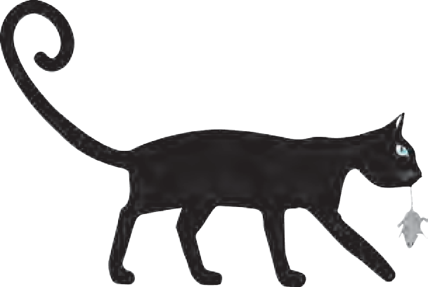

***Why was the Captain of the ship so overjoyed?***

**mouser :** an animal that catches mice

***What happened when food was brought in, at the palace?***

**plague :** (here) a thing that causes great trouble

***Why was the queen afraid of the cat?***

“Then let your cat go on the ship,” said Mr Fitzwarren. His daughter, Alice, said, “Dick loves his cat. Let me put something in for him.” But her father said, “No, it must be his, not something belonging to someone else.”

So Dick fetched his cat and said goodbye to it sadly. The captain of the ship was delighted, for the cat was an excellent **mouser** and so he had no trouble with rats and mice on his voyage.

After some months the ship arrived at a place on the African coast, Barbary, where people called the Moors lived. The captain sent a message to the king to say he had fine goods for sale and he was invited to the palace to show them. While he was talking to the king and queen some dishes of food were brought in, but almost immediately rats and mice ran up and before the captain’s eyes, ate all the food. The captain was astonished and asked if this was what normally happened.

“Alas, yes !” came the reply. “The country is suffering from a **plague** of rats and mice and we cannot get rid of them.”

“I think I may have the answer on my ship,” said the captain, and he sent a message asking for Dick’s cat to be brought to the palace. More food was laid out and the rats and mice appeared as before. The cat immediately pounced, killing at least a dozen before they scattered. Everyone was delighted and the queen asked, “What do you call this animal ?”

“Puss is the name she answers to,” said the captain and when the queen called, “Puss, puss,” the cat went over to her and purred. The queen was a little alarmed at first, as she had seen how fiercely the cat had

attacked the rats and mice, but the captain told her not to be anxious. “Puss is very friendly with people,” he said, “and would soon rid your kingdom of rats and mice.”



“I would give great wealth to own this animal,” said the queen.

So the captain began bargaining and it was agreed that the king would buy the whole cargo from Mr Fitzwarren’s ship to pay a fine price for it and for the cat alone the king paid ten times the sum again.

When the ship came back to the Port of London, the captain showed Mr Fitzwarren the gold and jewels he had brought from Barbary and told him the story of the cat, the merchant sent for Dick. “From now on, Dick” he said, “we should all call you Mr Whittington, for you are a rich man.’’ Mr Fitzwarren then paid him all the money the captain had received for the cat.

From this time on Dick worked with Mr Fitzwarren and became a successful merchant himself. He married Mr Fitzwarren’s daughter Alice and three times he was elected Lord Mayor of London. He was also in time **knighted** by the king and became Sir Richard Whittington. He was not only famous, but he was popular too, for he always helped the poor with his money. Sometimes when he was old, he would tell his grandchildren the story of his cat, and how the bells of London had called him back when he was only a poor boy :

***How much did the king pay for the cat?***

**knighted :** given a highly honoured title

***What changes had the cat brought to Dick’s life?***

*Turn again Whittington, Thou worthy citizen, Lord Mayor of London.*

**

1. **(A) Arrange the following set of words in the alphabetical order in your notebook.**

ship, small, successful, scoldings, stone, saving, someone, stood, streets, still, screamed, sat, seemed, saint, share.

**(B) Remove the Affixes (Prefix and Suffix) and write the Root-word.**

(1) successful (2) immediately

(3) retrace (4) mouser

(5) unfriendly (6) fallen

(7) unkind (8) wooden

(9) luckily (10) belonging

1. **(A) Find from the story one word for the following.**
   1. a small room just below a sloping roof
   2. a very narrow passage between buildings
   3. the highest - ranking officer in the Municipality of a city/town
   4. the highest ranking official who commands a ship
   5. any animal that catches mice
   6. a low constant sound made by cats
2. **Make sentences of your own using the following expressions.**
   1. overcome :
   2. put up with :
   3. bargain :
3. **Rearrange the following events as they occur in the story. Put the correct number in the boxes.**
   1. Mr Fitzwarren provided shelter to Dick.
   2. A carter gave Dick a lift to London.
   3. The cat sailed to the African coast.
   4. The captain sold the cat for a very high amount of money.
   5. Dick left his village on foot, to go to London.
   6. Dick became rich, and later, the Mayor of London.
   7. Dick was homeless, helpless, cold and hungry.
   8. Dick bought a cat to get rid of the mice.
   9. The rats and mice ate up all the dinner, laid for the king and queen.
4. **Think and answer.**
   1. What decision taken by Dick changed his fortune?
   2. What message does this story bring out for youngsters?
5. **(A) Break the words below into syllables as shown in the first one.**
   1. belonging : be - long - ing (f) morning :
   2. unfriendly : (g) citizen :
   3. anything : (h) message :
   4. difficulty : (i) mayor :
   5. captain : (j) elected :
6. **Degrees of Comparison of Adjectives. Read the sentences.**
   1. Yatin is strong.
   2. Amit is stronger than Yatin.
   3. Pravin is the strongest of all.

In sentence (i) the Adjective ‘strong’ is in its simple form. It is called

**Positive Degree.**

In sentence (ii) the Adjective ‘stronger’ refers to a higher degree, when there is a comparison of two nouns. It is called **Comparative Degree**. (-er is added to the basic Adjective)

In sentence (iii) the adjective ‘strongest’ refers to the highest degree of comparison of one with more than two nouns. It is called **Superlative**

**Degree**. (-est is added to the basic Adjective)

**Complete the table of degrees of comparison.**

|  |  |  |
| --- | --- | --- |
| **Positive** | **Comparative** | **Superlative** |
| (1) great |  |  |
| (2) famous |  |  |
| (3) | easier |  |
| (4) | worse |  |
| (5) |  | poorest |
| (6) |  | laziest |
| (7) little |  |  |
| (8) | worthier |  |
| (9) popular |  |  |

1. **Select any one of the famous personalities mentioned in ‘Warming up 1’ on page no. 5. From the library or internet find out their success story. Write it in your own words in about 20 to 30 lines of your notebook.**

**Give your write-up a suitable title.**





# The Pilgrim



* + 1. **Make groups and discuss the following :**
       1. What fatal dangers / problems did mankind face centuries ago, but are no longer a threat today?
       2. Name a few scientists / explorers /social reformers / inventors / discoverers, who spent most of their lives to find solutions to some major problems / setbacks, that mankind faced.
       3. Did they themselves suffer from those problems / setbacks?
       4. What inspired them to spend the best part of their lives to research and share their findings?

1. **Read and understand the following poetic devices.**
   1. If two or more words in the same line convey the same meaning, the Figure of Speech in that line is called **Tautology.**

For example : It brought joy and cheer.

They groaned with aches and pains.

* 1. Poets often change the proper grammatical order of words in the line of a poem, in order to make the lines rhyme or to emphasize upon something. The Figure of Speech in such lines is called ‘**Inversion**’ or ‘**Anastrophe**.’

For example : Up came the sun. Down the hill, it flowed.

* 1. When a question is asked in order to create a dramatic effect and not to get an answer, in a line of the poem, the Figure of Speech used is called **Interrogation / Rhetorical Question** :

For example : What is this life, if full of care?

When can their glory fade?

# The Pilgrim

A pilgrim, going a lone high way Came at evening, cold and gray

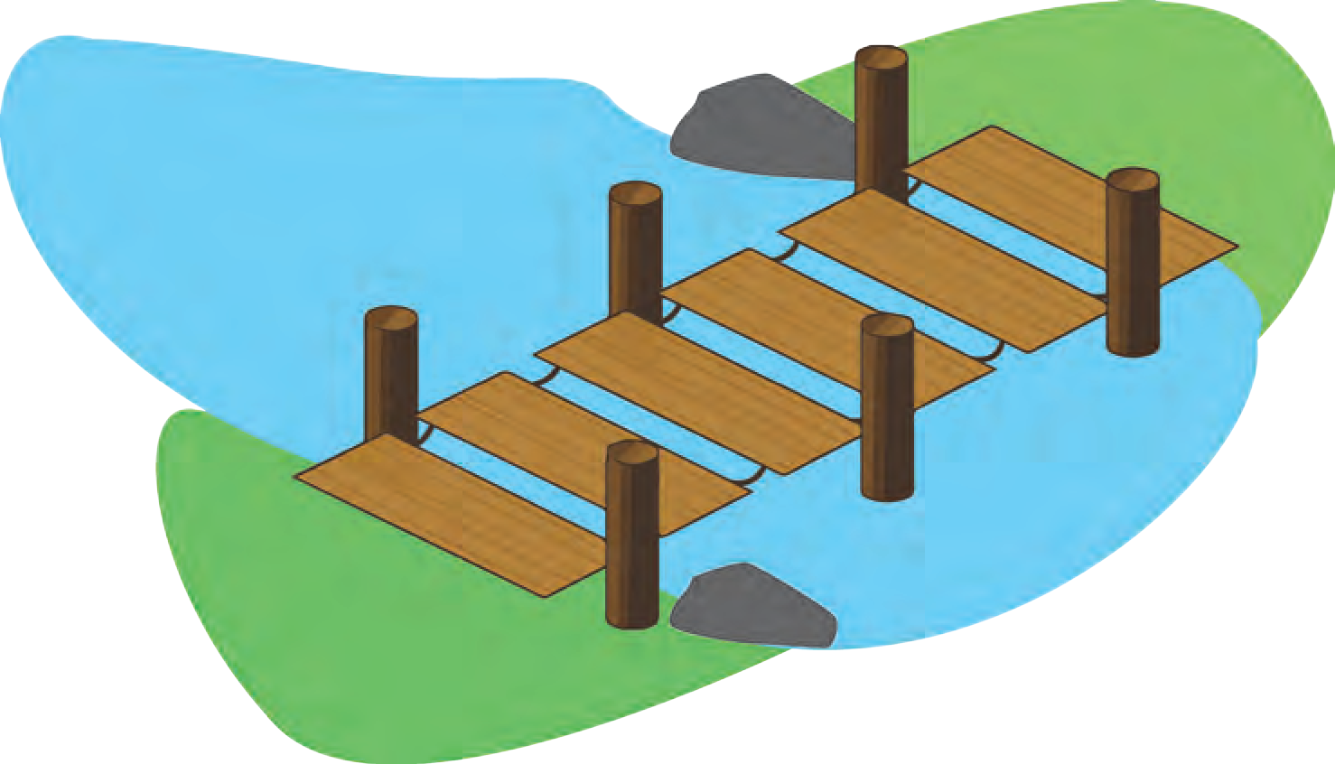

To a **chasm**, deep and vast and wide. The old man crossed in the twilight dim. The chasm held no fear for him.

But he paused when he reached the other side And built a bridge to **span the tide**.

“Old man,” said a fellow pilgrim near, “Why waste your time in building here? Your journey ends with the close of the day You never again will pass this way.

You have crossed the chasm deep and wide Why build **ye** here at **even tide** ?”

**chasm :** ravine, a very deep, steep gap in the earth’s surface

***What did the pilgrim do, although he had already crossed the chasm?***

**span the tide :** go across the tide

***What puzzled the fellow pilgrim?***

**ye :** (*archaic)* you

**even tide :** late evening

The pilgrim raised his old gray head,



***What could be the third pilgrim?***

**pitfall :** trap

“My friend in the path I’ve come,” he said, “There followeth after me today

A fair haired youth, who must pass this way. The chasm which held no fears for me

To the fair haired youth, may a **pitfall** be. He, too, must cross in the twilight dim.

My friend, I am building this bridge for him.”

*- Anonymous*

**

1. **Pick out words from the poem to fill in the web diagram. They should be related to the theme in the web.**

**Travel**

**Time around sunset**

1. **The entire poem is metaphorical (Implied comparison).**

**Match the words in Column A with what they imply in Column B. A B**

* 1. pilgrim (a) threat to life
  2. journey (b) trap
  3. evening or close of day (c) life
  4. chasm, deep and wide (d) death
  5. building a bridge (e) old age
  6. pitfall (f) a dutiful man
  7. close of day (g) solving the problem / getting rid of threat to life

(1)  (2)  (3)  (4) (5)  (6)  (7) 



14

1. **(A) Read the poem and write 3 qualities of each of the following.**

The old pilgrim The fellow pilgrim

The young pilgrim

1. **Answer in your own words.**
   1. Why did the old man have no need to build the bridge, across the chasm ?
   2. What explanation did he give to the fellow- pilgrim for his thoughtful deed ?
   3. What message does the poem convey to all of us ?
2. **(A)** Note the rhyming words in the first stanza. way - gray / wide-side- tide / dim -him.

The poet has used a deliberate pattern of lines that rhyme with other lines in the poem or the stanza. This pattern can be identified by giving the rhyming pairs of words the same letter of the alphabet.

For example: 1st stanza of this poem has the pattern AABCCBB

So, AABCCBB is called the **Rhyme Scheme** of the 1st stanza of the poem ‘The Pilgrim’.

1. Now write the Rhyme Scheme of the 2nd stanza ............. and 3rd stanza ............. *Remember that a line in the 2nd or 3rd stanza may rhyme with lines in the 1st stanza, too. You may use the same letter of the alphabet as used in the 1st stanza.*
2. Find two lines that contain Inversion. 1.

2.

* **Pick out one line each that contains the following Figures of Speech.**
  1. Tautology :
  2. Personification :
  3. Interrogation :

1. **Imagine that you are the fellow pilgrim and you wish to share your experience of the incident in the poem. Write a short article about it for a magazine / journal. Also convey what change it has brought in your life.**

# Revathi’s Musical Plants



1. **Discuss in groups and share your answers with the class.**
   * Can you name the famous musician in Emperor Akbar’s court, who could perform miracles, when he sang different Ragas?
   * What miracles could he perform with his music?
   * What impact does music have on human beings?
   * Do you think music can have an impact on animals, birds and even plants?
2. **Affirmative and Negative sentences**

Read the sentences below and spot the difference in their framing :

1. (a) I could not complete the work.
   1. I failed to complete the work.
2. (a) There is no sense in what you say .
   1. There is hardly any sense in what you say.
3. (a) He said he wouldn’t go.
   1. He refused to go.

You will observe that sentences marked (a) and (b) convey the same meaning. But in all sentences marked (a) there are negative words (no, not, wouldn’t) whereas the ones marked (b) do not have them.

Negative words are those that convey a negative meaning.

For example : never, no, neither, nor, not, cannot, don’t, isn’t, nothing etc.

If a sentence contains Negative words, it is called a NEGATIVE SENTENCE.

If a sentence does not contain any Negative word, it is called an **Affirmative sentence.**

Say whether the following sentences are **Affirmative or Negative** ones.

* + 1. We must avoid hurting others.
    2. She didn’t offer me any help.
    3. Never give up hopes.
    4. You must keep away from bad company.
    5. There is nothing in the bag.
    6. Entry is prohibited, without permission.

**Note :** While interchanging Negative and Affirmative sentence, the meaning and tense must not change.

You **must** use Negative words in the sentence, while converting from Affirmative to Negative.

You may use words like hardly / fail to / refuse / reject / avoid / prohibit / without / ban etc., while changing Negative sentences to Affirmative.

# Revathi’s Musical Plants



**balsam :** a plant, usually with pink or white flowers, grown in gardens

**stunted :** slowed down or stopped

***Why did Revathi change the pot’s location?***

***Name the favourite raga of Revathi.***

**struck her as odd :**

seemed very strange

***What strange thing did Revathi notice about the potted plant?***

***How did Revathi confirm her new discovery?***

Revathi was a student of music. She was happy playing on her violin whenever she was free. There was a small

open courtyard in front of her house, with a small cement bench. She would sit on the bench and practise on her violin. There were a few potted plants in the courtyard. While playing on the violin one day, she noted a pot of **balsam** plants near the wall. The plants were not looking normal. They had pale green leaves and their growth was **stunted**. She remembered she had learnt in the lower classes that plants need light for normal growth. She shifted the pot to the centre of the courtyard where there was ample sunlight.

While shifting the pot, an idea struck Revathi. Why not participate in the ‘Best plant’ contest which was to

be held in her colony a few weeks later! Then and there she decided to participate. Thus making up her mind, she watered the plants and sat down on the bench and started playing her violin. She was very fond of the raga ‘Mohanam’. She played the raga for some time and then went in for her studies.

Everyday, Revathi would sit on the bench and watch her potted plants. They were growing well and looking healthier than the other plants in the far end of the courtyard. One day as she was playing, she noticed a movement in her potted plants. They were slowly moving their stems, bending slightly towards her. She wondered why they were moving as there was no breeze. It **struck her as odd**.

The next evening too she played on her violin as usual and watched the potted plants with care. After some time, like the previous day, there was a definite movement

in her plants. They all bent towards her. This astonished and surprised her. That day also, there was no breeze.

Revathi sat on the bench and played a different tune, one with a quick rhythm. She suddenly saw all plants turn away from her as though they did not like what she was

playing. Then she started playing her favourite tune again and the plants slowly straightened themselves and bent towards her. Her **surmise** became a certainty. Her plants loved to hear her favourite tune.



**surmise :** guess

**mauve :** of a pale purple colour

**knew no bounds :**

had no limits

***What shock did Revathi receive on the prize distribution day?***

She kept the knowledge a secret. She did not tell anyone, not even her mother. There were only a few days left for the prize distribution. To her great surprise, Revathi found her potted plants not only taller and healthier than other balsam plants, but that they had started flowering a few days earlier than the other plants. The flowers were big and brightly coloured and one of the plants had an unusual

kind of flower. The flowers were **mauve** with white stripes. That evening she knew, she would definitely get the prize for the best plants. She went to bed, dreaming of her plants and the new type of flowers. The next day was the all - important day. She got up in the morning and went straight to the courtyard to see her plants. Revathi blinked for a few minutes, for there was neither the pot nor the plants. She looked to see if someone had moved the pot. She searched all over. She asked her mother. Her mother said she knew nothing either about the pot or the plants. Some of the neighbours had been to their house the previous afternoon and had remarked at the beautiful flowers and the healthy

- looking plants in the pot. But later, she had been busy inside the house and had been not to the courtyard.

Revathi’s grief **knew no bounds**. She went around asking every one of her neighbours but no one had been anywhere near the pot of plants. She could not lodge a complaint for a pot of plants. She felt as though everything was lost. She did not mind, not getting the prize but she really missed her plants. She had grown very fond of them. They were her friends, who enjoyed her music.

That evening, all her friends were going to the prize distribution ceremony. She did not want to attend. But her friends forced her to. After reaching the place, she went to the benches where the potted plants were displayed. Revathi was shocked. There was her pot of plants on a bench, with the name of a **distant** neighbour of hers as the competitor written on a small piece of cardboard and placed in the

soil. She knew it was her pot of plants. She went to the organisers of the show and told them about it.

The organisers were not convinced. They said, ‘‘How can you prove that the plants are yours? The lady who submitted them is a regular participant. How can we doubt her?’’

Revathi wondered how to convince them. She sat there for a few minutes looking at the plants. The sight of the plants bending towards her while she played her violin flashed across her mind. She told the organisers that she could prove the plants were hers. She ran home. When she returned a few minutes later with her violin in, they started laughing.

But their **ridicule** did not **deter** her from her **mission**. She told them, ‘‘I know my plants and I share a secret with them. My plants are music - lovers like me and you could see how they respond when I play to them.’’

They all laughed louder saying that they had never heard of plants enjoying music. They asked her, ‘‘Do plants have ears like us to enjoy your music?’’ No one believed her.

***How did Revathi plan to convince the organisers that the plants were hers?***

***Why did the organisers refuse to believe that Revathi’s plants were music lovers?***

**ridicule :** unkind laughter

**deter :** discourage

**mission :** an important task undertaken

She felt very **dejected** but was determined to win her plants back. She sat near her plants with her violin and slowly started playing her favourite raga. Engrossed in her music, Revathi even forget her plants for a time, but the others could not.

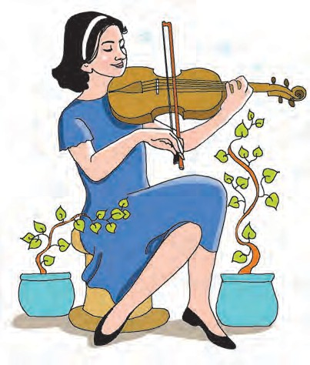

With wonder in their eyes, they watched the plants. Straight at first, they bent slightly. As she played on and on, their stems bent towards Revathi as though

they wanted to touch her, in their happiness. The organisers were **stunned**. They had watched a new

**dejected :** sad, disappointed

**stunned :** astonished and amazed

**phenomenon** of plants responding to music and Revathi had become a great discoverer.



**phenomenon :** something that is very unusual

**applauded :** showed praise by clapping

**pulled up :** told someone they had done something wrong

***Why had no one suspected that the neighbour had stolen the plants?***

***What is the happy end?***

They all **applauded** her and said they were convinced that the plants were hers.

They **pulled** her neighbour **up** for cheating them and she accepted, after a long argument, that she had stolen Revathi’s plants. She said while walking past Revathi’s house she had spotted the plants and had removed the pot in the night to her house and submitted it later for the contest. As she was a regular participant, no one doubted her.

The authorities decided that Revathi’s plants deserved the first prize as they were the best - looking and healthy. Revathi carried home the prize proudly with her pot of plants.



1. **Read the story and complete the following.**
   1. At first, Revathi’s plants did not look normal and healthy because,
   2. When Revathi played her favourite raga, the plants began to move because,
   3. Revathi’s grief knew no bounds because,
   4. Revathi was confident of proving her ownership of her pot of plants because,
   5. Revathi won the prize for the ‘Best plant’ because,
2. **Answer in your own words.**
   1. What did Revathi discover about her balsam plants?
   2. Why did she decide to keep her new knowledge ‘a secret’?
   3. How did the plants respond when Revathi played her favourite tune?
   4. How did the plants react to the fast rhythmic music?
   5. How did Revathi prove to the organisers of the competition, that the plants truly belonged to her?
   6. What helped Revathi to claim her plants - her belief in magic or the belief in her convictions? Explain your choice.
3. **(A) A word chain consists of words of a certain category that begin with the letter that the previous word has ended with.**

Complete the word chain adding four nouns from the text.

Music - courtyard - d ............... , .............. , ............... , ............... .

1. **Add the appropriate Prefix to make the following words oppposite in meaning.**
   * continue  possible  certain
   * definite  believe  important
   * place  known  regular
2. **Use the following expressions to make sentences of your own.**
   * make up one’s mind  flash across one’s mind
   * struck as odd  to surmise
   * knew no bounds  not to deter
3. **Imagine there is a ‘Best Plant’ Competition in the locality / colony where you live. Frame a Notice about the same, in the form of an attractive poster.**

**Cover the following points.**

(1) Name of the organisation (2) Name of the Contest

(3) Day, Date, Venue (4) Who can participate

(5) Prizes (6) Contact details for further enquiry

1. **Types of sentences**

Study the following sentences.

Set (A)  Revathi was a student of music.

* The flowers were big and brightly coloured; indeed.
* They were requested to believe her.

All the above sentences are statements or assertions, and called **Assertive** or **Declarative sentences.**

Set (B)  Wasn’t Revathi a student of music?

* How can we doubt her?
* Do plants have ears?

The above sentences in Set (B) are Questions. They are called **Interrogative sentences**. Set (C)  Please believe me.

* Let us watch the fun.
* Sit straight.
* Excuse me.

In Set (C) the sentences are either requests, appeals, commands, suggestions etc. Such sentences are called **Imperative Sentences**.

Set (D)  How big and bright the flowers were !

* What a surprise !
* Ah, what beautiful music that is !

Set (D) has sentences that express strong feelings. They are called **Exclamatory Sentences**.

State the kinds of the following sentences.

1. How happily she played the violin!
2. They all bent towards her.
3. Don’t play that quick tune.
4. She kept the knowledge a secret.
5. How can plants enjoy music?
6. How proudly did Revathi carry home her prize!
7. What could have taken my plants?
8. The organisers were not convinced.
9. **Make the following Negative using the negative words given.**
10. There were a few potted plants in the courtyard. (not many)
11. They looked healthier than the other plants. (not as healthy as)
12. She refused to share her secret. (would not)
13. She went around asking everyone about her plants. (No one / did not)
14. **Make the following Affirmative using the words given.**
15. There was no breeze. (hardly)
16. Their ridicule did not deter her. (failed to)
17. Her mother knew nothing about it. (denied)
18. She did not give up. (refuse to)
19. **Imagine that Revathi’s father is abroad on business and she wishes to convey the news of her prize - winning plants. Draft an email for the above subject.**

(Use an email format.)



22



**WORD PLAY ANAGRAMS**



An anagram is a play on words created by rearranging the letters of the original words to make a new word or phrase. Anagrams can be fun and witty. We can often find examples of anagrams in everyday life.

For example : state - taste, dusty - study, save - vase, thing - night, etc.

**Group Activity :** Divide the class in four groups. The first group finds out anagrams of 3 letters, the second group finds out anagrams of 4 letters, the third and fourth groups find out anagrams of 4 and 5 letters respectively, in the given time. The group which collects maximum anagrams in the given time, will be the winner.

**Individual Activity :** Make anagrams of the following words. Remember that an anagram contains exactly the same letters, no more no less, only in a different order.

* ten • dairy • glean • former • auctioned • listen • allergy • funeral • teacher • dormitory

**MOTHER TONGUE OR OTHER TONGUE?**

There are some words in English which sound like words in your mother tongue. But, if you consider the meaning and use, you realize that they are different words altogether. For example :

|  |  |  |  |
| --- | --- | --- | --- |
| **Words** | **Meaning in English** | **Meaning in Marathi** | **Meaning in Hindi** |
| Rose | a flower | daily | everyday |
| Sun / Son | a star / a male heir | festival | year |
| Piece / peace | a bit / calm | a feather | grind |
| calm | peaceful | work | work |

**Activity :** Now complete the following table.

|  |  |  |
| --- | --- | --- |
| **Words** | **Meaning in English** | **Meaning in Marathi** |
| Boat |  | a finger |
|  |  | daughter-in-law |
| Rope | a strong cord |  |
| Lake | a body of fresh water surrounded by land |  |
| name | a word/words by which a person or thing is known |  |
| more | greater in amount or degree |  |
| case | container |  |

Find more such English words which would be meaningful in your mother tongue, too.

23

**Riddles**



**Group Activity :** The teacher divides the class into four groups. The teacher asks the groups to read the riddles and choose the correct answer for each one. The group that finishes correctly first is the winner.

* What comes down but never goes up ?
* What has hands but cannot clap?
* Everyone has it and no one can lose it. What is it?
* What has an eye but cannot see?
* I have teeth but I cannot bite. Who am I?
* What starts with P and ends with E and has more than 1000 letters?
* Where does Friday come before Thursday?
* We see it once in a year, twice in a week and never in a day. What is it?
* What can travel around the world while it remains in a corner?

(a date / a comb / the letter ‘E’ clock / your name / a bottle / a stamp / in a dictionary / rain / a shadow / post office / needle)

Collect / make up your own riddles in a group and present before in the class.

1. **Word Building**
   1. **Reduplication :** The root / stem of a word is repeated exactly or with a slight change.

For example, tweet-tweet, pitter-patter, chit-chat, bang-bang, riff-raff.

* 1. **Blending :** Parts of two or more words combine to form a new one. For example :  breakfast + lunch = brunch
     + smoke + fog = smog
     + motor + hotel = motel
  2. **Clipping :** Reducing a word to one of its syllables or a part of it. For example :  Mathematics - Maths
     + Advertisement - Ad
     + Laboratory - Lab
  3. **Acronym :** Words formed from the first letter of each of the words involved.

For example:  radar, scuba, Unicef, Nasa

* + - BBC, CID, USA, ATM, VIP
    - DOB, KYC, PM, GN, TY etc.

In your notebook, write five examples of each of the above types of word-building devices. (You may take the help of a Dictionary / Internet.)

24



**(A) Grow a Sentence :**

* Frame a meaningful sentence in English. It should be short and simple. For example : ‘Yesterday , I bought a story book’.
* Write it down on a card.
* Next day try to expand the same sentence.

For example : Yestreday, I bought a story book written by Leo Tolstoy.

* On the third day, expand the previous sentence even more.

For example : Yesterday, I bought a story book written by Leo Tolstoy, who is a famous Russian writer.

* Keep this up, till you can.
* Make sure there is connectivity and proper meaning to your final output.
* Confirm if your final sentence is appropriate, from your teacher.

**(B) A Proverb a day**

* Choose a Proverb every day.
* Try to understand its meaning and implied meaning if any.
* Write the proverb in a separate book and explain its meaning (in a different font). For example : A stitch in time saves nine.

*(Bad habits or weaknesses should be controlled / corrected in time before they become a habit.)*

* Now write a new proverb each day till you have a good collection of at least 25 to 30 proverbs along with their meaning in simple words.
* You may share and discuss with your teacher / parents / classmates.

**(C) Expressions!**

Using a similar pattern, as for proverbs think of a situation and what expression comes out spontaneously in spoken English.

For example : Situation - shock

Expression - Oh no ! Situation - Joy

Expression - Wow! How lovely !

25

# Vocation



1. **Pick out words that refer to ‘means of living’ and fill them in the Web.**

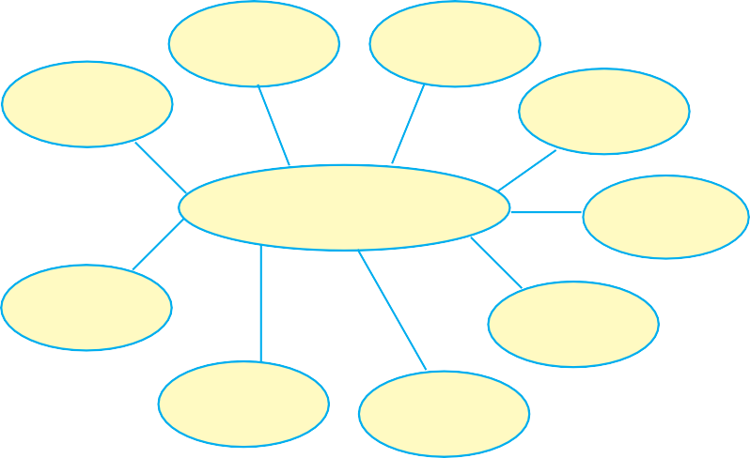

(profession / recreation / occupation / job / pastime / employment / hobby

/career / entertainment / mission / trade / buisness /sports /retirement / placement)

**Means of Living** Vocation

1. **Using a good dictionary, find the shades of difference in the following :**

‘Profession’ refers to ‘Vocation’ refers to ‘Business’ refers to ‘Occupation’ refers to

1. **When a word is formed from a sound associated with it, it is called an Onomatopoetic Word.**

For example : bang, tap, tinkle, crash, whistle etc.

If an Onomatopoetic word occurs in the lines of a poem, the Figure of Speech in that line is **Onomatopoeia**.

Write down eight to ten Onomatopoetic words on your own.

# Vocation

When the **gong** sounds ten in the morning and I walk to school by our lane,



Every day I meet the hawker crying, ‘‘Bangles, crystal bangles!’’

There is nothing to hurry him on, there is no road he must take, no place he must go to, no time when he must come home.

I wish I were a hawker, spending my day in the road, crying, ‘‘Bangles, crystal bangles!’’ When at four in the afternoon I come back from the school,

I can see through the gate that house the gardener digging the ground.

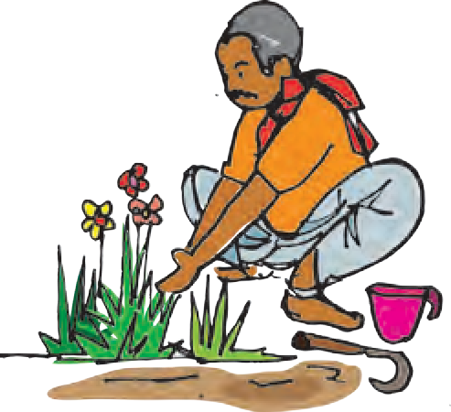He does what he likes with his spade, he soils his clothes with dust, nobody **takes him to task**, if he gets baked in the sun or gets wet.

I wish I were a gardener digging away at the garden with nobody to stop me from digging. Just as it gets dark in the evening and my mother sends me to bed,

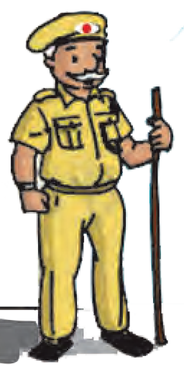I can see through my open window the watchman walking up and down

The lane is dark and lonely, and the street lamp stands like a **giant with one red eye** in its head.

The watchman swings his lantern and walks with his shadow at his side, and never once goes to bed in his life.

I wish I were a watchman walking the street all night,

**chasing the shadows** with my lantern.

*- Rabindranath Tagore*

**gong :** a flat metal bell rung to draw people’s attention

***What does the hawker advertise aloud?***

**takes someone to task :** scolds and corrects

**one-eyed-giant :** reference to a character from Greek Mythology (Homer’s Odyssey)

***Who is scolded if he gets dirty?***

***What accompanies the watchman?***

**chasing the shadows :** following an imaginary goal/ target



1. **Which of the following words / phrases match in meaning to the underlined ones?**

(a) deserted (b) exposed to heat

(c) dirties the clothings (d) no particular route

(e) following imaginary goals (f) scolds and corrects

1. nobody takes him to task
2.  if he gets baked in the sun
3.  chasing the shadows with my lantern
4. The lane is dark and lonely
5.  he soils his clothes with dust
6.  There is no road he must take
7. **Read the poem and fill in the table**.

|  |  |  |  |  |  |
| --- | --- | --- | --- | --- | --- |
| **Time of the day** | **Location** | **Poet’s Activity** | **Hawker’s Activities** | **Gardener’s Activities** | **Watchman’s**  **Activities** |
| Morning |  |  |  |  |  |
| Afternoon |  |  |  |  |  |
| Night |  |  |  |  |  |

1. **Think and answer in your own words.**
   1. What could be the age group of the speaker in the poem?
   2. What is the difference between a hawker and a shopkeeper?
   3. How do parents react when they see children soil their clothes in dust and heat?
   4. Why is the street light compared to a one-red-eyed-giant?
   5. What exactly does the speaker in the poem crave for?
   6. Does the poet really wish to become a hawker/gardener/watchman? Justify your response.
2. **Say why the speaker of the poem wishes to be a -**

(a) hawker (b) gardener (c) watchman.

1. **Pick out lines that contain Alliteration, Simile, Repetition, Onomatopoeia.**
2. **Some poets do not use uniformity in rhyming words, nor a steady rhythm. Such poems with no uniformity in rhyme, rhythm, length of lines or stanzas are called Free Verse. Walt Whitman, Ezra Pound, T.S. Eliot, Rabindranath Tagore are some famous poets who have composed poems in Free Verse.**

A quick glance at the poem ‘Vocation’ reveals that the style used by Tagore is Free Verse.

Now turn the pages of your textbook and see if you can find other poems in Free Verse.

1. **What vocation / profession / business would you like to take up in future? Prepare a fact file for the same using the following points.**
2. Name of the vocation / profession / business
3. Educational qualifications required
4. Work profile / description
5. Opportunities for advancement
6. Your personal skills / talents for the choice
7. **Read and understand the following poem ‘Paper Boats’ and write its paraphrase in your own simple language. (You may take the help of dictionary or internet.) The first line is done for you.**

(Day after day, one after another, I sail paper boats on the stream of flowing water.)

**Paper Boats**

Day by day I float my paper boats, one by one on the running stream.

In big black letters I write my name on them and the name of the village where I live.

I hope that someone in some strange land will find them and know who I am.

I load my little boats with shiuli flower from our garden, and hope that these blooms of the dawn will be carried safely to land in the night.

I launch my paper boats and look up into the sky and see the little clouds setting their white bulging sails.

I know not what playmate of mine in the sky sends them down the air to race with my boats !

When night comes I bury my face in my arms and dream that my paper boats float on and on under the midnight stars.

The fairies of sleep are sailing in them, and the lading is their baskets full of dreams.

*(****Note :****‘lading’ means cargo loaded in a ship.)*

**



# Nature Created Man and Woman as Equals



1. **Study the pictures below and note down the differences.**

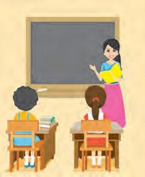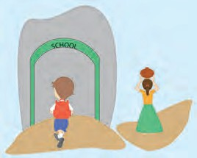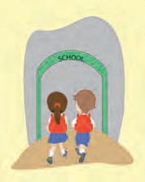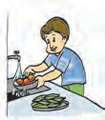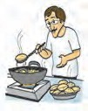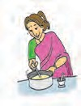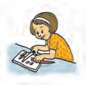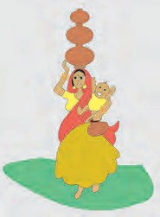

Differences

Differences

1. **Now write what you observe in the following two pictures.**
2. **Which pictures reflect gender equality? Write their numbers.**
3. **Write down any two Slogans on ‘Gender Equality’.**

(1)

(2)

# Nature Created



**nestles :** is close to

**rolling :** extending

in long gentle slopes

**fragrance :** pleasant smell

***Make a list of the beautiful natural surroundings of the house.***

***What help did Lanthoi need from her mother?***

**symposium :** a meeting at which experts have discussion on a particular subject

**presses on :** persuades some one to do something

***What did Lanthoi’s father work as?***

**discriminate :** treat one person or group better or worse than another, in an unfair way

***In what way did Tomba contribute towards Ashangbi’s success?***

**Man and Woman as Equals**

The house and its surroundings are a sight of peace in the early morning of April. It **nestles** by the side of a small stream of crystal-clear water. The stream tumbles down the green mountains only two miles or so away. There is a stretch of hundreds of acres of fertile land **rolling** with yellow mustard flowers, between the mountain range and the house. A garden is in front of the house. Trees of many kinds bearing flowers of various hues and fruits grow on all sides of the house.

The courtyard smells of jasmine which blooms in bunches of white pearls. The **fragrance** mingles with the thin smoke that rises from sweet smelling incense sticks. The burning incense sticks are glowing at the altar of God in the middle of the courtyard.

Ashangbi is in her reading - room and is busy writing an article. She is a middle - aged mother of three children and a journalist and woman’s rights activist. Lanthoi, her youngest daughter, enters the room. She is an intelligent girl. Today she looks thoughtful and she takes a seat by her mother’s side. At the sight of her child, Ashangbi lovingly asks, “Have you finished your study, my dear ?” “Yes, mother, I finished it last night. Today being Sunday, I want to do something interesting.” Lanthoi says and waits for her mother’s response. “Tell me what you want to do,” Ashangbi asks her quite amused. “Mother, tomorrow I’m going to represent the Siroi Lily House as a speaker in a **symposium** at our school. The topic is ‘God Created Men and Women As Equals’. Will you spare some time to have a discussion with me?” Lanthoi **presses on** her mother.

Lanthoi has just had a discussion with her father on the topic. Tomba, her father, is a husband supportive of the activities of his wife and a loving father. He is a lawyer and a socialworker, who advocates the cause of women. He is always proud of his wife, the two daughters and the son. In times of need, he extends his helping hand to his wife and children and to the society at large. He does not **discriminate** between a man’s work and a woman’s work anywhere. He shares

equally with his wife in doing the household chores like cleaning, washing, cooking and feeding the children. Had he not shared in these activities in the way he does, his wife would not have been a successful professional. He wholeheartedly believes in equality irrespective of class, religion and **gender**. In his discussion with his daughter, he **laments** over the great injustice done on women in the society, telling her, “My dear child, the world is still full of inequalities. We have to find a way to bring equality between men and women”.



**gender :** fact of being male or female

**laments :** expresses grief and sorrow

***How did mother explain Lanthoi’s topic for her speech at school?***

**subjugated :** controlled and dominated over

***How is the role of a mother honoured and praised?***

**glorified :** praised

**pioneer :** a person who is among the first to take up a cause especially in a new region.

**testify :** provide proof / evidence

Her father’s words are still ringing in the ears of Lanthoi. And she tells her mother of what her father has told her.

Appreciative of her husband for his views, Ashangbi says, “Your father is right. In no society do women enjoy the same opportunities enjoyed by men. It is because of your father that I feel no difference or inequality at home. But, outside our home, I have seen that women have been **subjugated** in many ways. It is against the will of God. God has sent men and women to our Earth to share the joys and sorrows of life equally, to share His blessings and to enjoy the bounty of Nature equally. This is what your topic means”.

Ashangbi knows well that men and women are equal. Women, who are half of the human race, are as important as men. She writes and talks about such topics. Her daughter, though a child, also understands well that her mother is not a person of lesser quality than her father. She says, “Our home is full of love with you, mother.”

The mother beams with joy at the words of her daughter. As a matter of fact, mother is the fountain of love in a family. This bond of love is beyond comparison with anything else in the world. It is because of this that motherhood has been **glorified** and women accept the challenges in life to become a mother.

Showing deep affection, Ashangbi continues, “**Pioneer** women **testify** to the equality of women with men. Actually, life is not possible without both women and men”.

Lanthoi has been fascinated by the stories of pioneer women. Her grandmother had narrated many

stories of the brave queens like Linthoingambi and Kuranganayani, who were as brave as kings. There were also many brave women among the common people. These women, as her grandmother narrated, were makers of home, family, society and the nation. They were **civilizing** influences. At the same time, they were also adventurers who claimed their shares in free land, ploughed and raised crops with their own hands and drove cattle. Modern women have become mountaineers, naturalists, astronauts, scientists, soldiers and political leaders. This proves that there is nothing a woman cannot do and also that women and men were created as equals.



Then she asks her mother further, “Mother, you’ve **thrown light on** the equality of men and women and also have emphasized that the world is still an unequal world. Then, what I would like to know is if there are moral, social and **legal** provisions to enable women to express their physical and mental **potential** and to set themselves free from suppression”. Amazed at the curiosity of her daughter, Ashangbi adds :

“There are many. **Under the aegis** of the United Nations, there is a declaration for a new world of equality. It has the following **dimensions** :

* 1. equal access to basic social services including health and education,
  2. equal participation in political and economic decision - making,
  3. equal reward for equal work, and
  4. **elimination** of discrimination and violence against women.”

Then the mother concluded, “My dear daughter, we can affirm along with the United Nations that men and women are equals.”

Lanthoi understands what her mother means and what the topic of the symposium means. Thus, confident of success, the next day, after thanking her mother, the girl of twelve happily rushes out of the room in the bright morning sun. The blue sky meets the range of the eastern mountains. The small girl is always fascinated by the small trail which winds up the distant purple mountain.

**civilizing :** educating

***What are the achievements of modern women?***

**throw light on :** to give information or explanation about

**legal :** related to law

**potential :** the qualities that exist and can be developed

**under the aegis :** with the protection or support of

(a particular organization or person)

**dimensions :** aspects

**elimination :** getting rid of

***What social justice does the aegis of the United Nations guarantee?***

***What vision meets her eye, when Lanthoi rushes outdoors?***

***What does that vision symbolize?***



1. **(A) Find from the lesson words / phrases that mean the following.**
   1. colours
   2. a person who writes for newspapers/magazines
   3. make a difference between
   4. cry over
   5. explain in detail
   6. abilities and qualities
   7. same availability
   8. a person who brings about a social/political change

**(B) Pick out five Compound words from the lesson.**

1. **Answer in your own words.**
2. Read and write down 5 points which prove that Tomba (Lanthoi’s father) firmly believes in gender equality.
3. In what ways is Ashangbi different from other women of her community?
4. What are the provisions in the Declaration of the United Nations, to ensure equality of men and women?
5. **Who said to whom and when / why?**

|  |  |  |  |
| --- | --- | --- | --- |
|  | **Who said?** | **To whom?** | **When / why?** |
| . the world is full of inequalities. |  |  |  |
| I want to do something interesting. |  |  |  |
| It is against the will of God. |  |  |  |
| Our home is full of love....... |  |  |  |
| . we can affirm along with United  Nations that men and women are equal. |  |  |  |

1. **We have studied in previous classes that Pronouns are words used instead of Nouns.**

We also know about Personal Pronouns like I, you, he, she, my, your, his, her, they etc. There are other words also which are used in place of nouns.

1. This, that, these, those point to some noun.

For example : ‘This is a kingfisher.’ ‘Those are herons.’ Such Pronouns are called

**Demonstrative Pronouns**.

1. Some pronouns not only replace nouns, but also connect two sentences. For example : ‘Biology is a science. It studies living organisms.’ Biology is a science which / that studies living organisms.

Some other such pronouns are who, whose, whom etc. They are called **Relative Pronouns**.

1. Some pronouns are used to ask questions. For example : What is your name?

Which is your coat? Who is your coach?

The underlined words are **Interrogative Pronouns**.

Underline the Pronouns in the following sentences and name their types.

* 1. What do you want to do?
  2. It is because of your father that I feel no inequality.
  3. This is what your topic means.
  4. She is fascinated by the small trail, which winds up the mountain.

1. **Read the following lines. Imagine it is the beginning of an instance you have experienced. Complete the incident using your imagination. Give it a positive ending.**

I had often noticed that in my neighbour’s family, the son was greatly pampered, but the daughter was treated unfairly. I could not bear this. So one day I decided to .......................

................

**Continue the write-up, with your own ideas, in about 12 - 15 lines.**

1. **Project :**

From your school library or internet collect quotations / slogans promoting gender equality. Make decorative posters with pictures of outstanding women or sketches or illustrations of your choice. With permission, put up the posters in your school surroundings.





# The Worm



* 1. **‘Worms play a very important role in maintaining ecological balance. They are friends of farmers.’**

Form groups and discuss the significance of worms in the above two roles.

* 1. **Think and write down how the following creatures can be useful :**
     1. Dragonfly :
     2. Spider :
     3. Ants :
     4. Honeybees :
     5. Earthworms :
  2. **Little creatures in nature can also be your teachers. Think and write what we can learn from the following.**
     1. Bees :
     2. Ants :
     3. Spiders :
     4. Caterpillars :
  3. **Breeding worms to use them to convert organic waste into fertilizer is called vermiculture or vermicomposting.**

Find out more about Vermiculture and how you can carry out the same in your garden / backyard, to fertilize your plants at home.

# The Worm

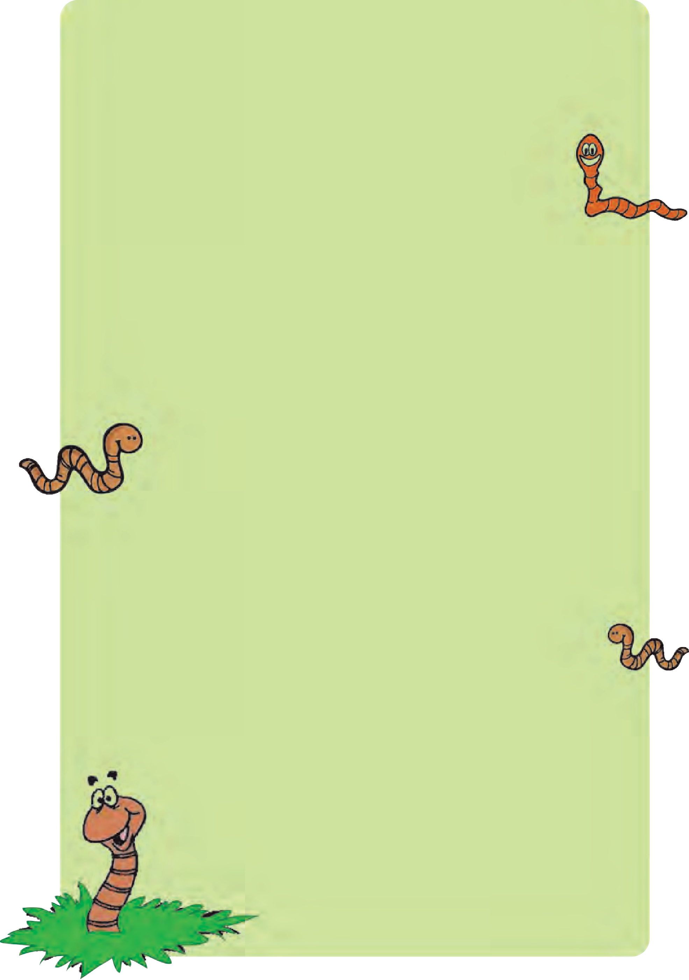

Turn, turn thy **hasty** foot aside, Nor crush that helpless worm !

The frame thy **scornful** looks **deride**

Requir’d a God to form.

The common Lord of all that move, From whom **thy being** flow’d,

A portion of His boundless love On that poor worm **bestow’d**.

The sun, the moon, the stars He made To all His Creatures free :

And spreads o’er earth the grassy blade, For worms as well as thee.

Let them enjoy their little day, Their **lowly bliss** received;

O do not lightly take away The life thou canst not give !

*- Thomas Gisborne*

**hasty :** hurried and careless

**scornful :** filled with hate

**deride :** express

hatred

***Why should we take care even of small worms?***

**thy being :** your life, existence

**bestow’d :** given as a gift

***What other***

***creations of God are mentioned?***

**lowly :** humble, simple

**bliss :** joy, pleasure

***Explain the thought in the last two lines in simple words.***

1. **Read the poem aloud and you will find some old outdated words that we do not use in everyday language now.**

However, some writers / poets use them to impart an old**-**fashioned flavour to suit the background of their write-up. Such words are called **Archaic words**.

Give the modern words for the archaic words from the poem. thy

being

bestow’d thee thou cans’t

**Read any poem / sonnet by William Shakespeare. Pick out archaic words and guess what they mean.**

1. **The poet uses a device where he directly addresses someone absent or abstarct. Such a device is the Figure of Speech called ‘Apostrophe’.**

For example : Turn, turn thy hasty foot aside.

* + **Pick out any two other lines from the poem that contain an Apostrophe.**

1. **Think and answer in your own words in your notebook.**
2. Why does the poet appeal to us, to respect the life of a worm?
3. Why do you think God created worms? What is their ecological importance?
4. ‘Live and let live’ is a famous proverb. Which lines from the poem support this proverb?
5. Does the poem urge us to protect only worms?

What is the general message conveyed through this poem?

1. **Find from the library or internet other poems composed on tiny living creatures. Try to understand the message in each of them.**
2. **‘Even small things in nature play a big role. So protect nature!’ Frame some slogans based on the above topic.**

 **Draft a short speech on the above topic, which you could give at your school assembly.**

 **Use the following steps while drafting.**

 Greeting  Salutation  Self - introduction  Introduction of the topic  Body of the speech  Conclusion

 Expression of gratitude to the audience

1. **Paraphrase the poem in your own simple language. Write it down in your notebook.**
2. **Frame a pointwise analysis of the poem ‘The Worm’. Use the following points.**
3. Poem and poet :
4. Theme :
5. Tone :
6. Structure and stanzas :
7. Rhyme and Rhythm :
8. Language and Imagery :
9. Figures of Speech :

# Three Visions for India



* 1. **Read the Preamble of the Constitution of India given in your textbook. Pick out words that refer to the following.**
     1. Brotherhood
     2. Freedom
     3. Earnestly and seriously
     4. Fair and impartial treatment
     5. Having supreme authority
     6. Unity and oneness
     7. A promise made to oneself
  2. **Finite and Non- finite Verbs.**

Verbs are Action words. They can be Finite or Non-finite. Read the sentences below, focusing on the verbs.

1. I play football.
2. He plays football.
3. They play football.
4. Manish plays football.

We notice that the verb ‘play’ as we change the person (First / Second / Third) or Number (Singular / Plural) of the Subject.

When the use of a verb is limited by the Person or Number of the Noun / Pronoun in the Subject, we call it a **Finite Verb.**

* Now read the sentences below.
  1. I like to play football.
  2. He likes to play football.
  3. They like playing football.
  4. Manish likes to play football.

In the sentences above the verb ‘to play’ or ‘playing’ do not change or take ‘-s’ or ‘-es’ after them, even when we change the Person or Number of the Subject.

to + verb / verb + ing / verb + en / ed / having + verb + en / ed are not limited by their Subject. Such verbs are called **Non-finite Verbs**.

# Three Visions for India



***What helped Dr Kalam fix the three visions for India?***

**vision :** a dream, an ideal

**standing up to :** being brave and facing challenges

**potential :** capacity, ability

**validated :** confirmed with proof

**took over :** took the authority of

**nurture :** develop

***How should we***

***handle our freedom?***

**globally recognized :** noticed and accepted all over the world

*D***r APJ Abdul Kalam,** the father of India’s integrated guided missile program, states three **visions**

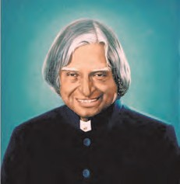for India based on the achievements and progress that he has witnessed in the history of the nation and during his own career, as a missile scientist. Dr Kalam’s three visions

for India are FREEDOM, DEVELOPMENT, and **STANDING UP**. The focus of his presentation is on developing India to its fullest **potential**, while **standing up to** the rest of the world with fully **validated** self- respect for the achievements that have been obtained in the modern times.

## If we are not free, no one will respect us.

I have three visions for India. In 3,000 years of our history, people from all over the world have come and invaded us, captured our land and conquered our minds. From Alexander onwards the Greeks, the Portuguese, the British, the French, the Dutch - all of them came and looted us and **took over** what was ours. Yet we have not done this to any other nation. We have not conquered anyone. We have not grabbed their land, their culture and their history, nor tried to force our way of life on them. Why ? Because we respect the freedom of others.

That is why my first vision for India is FREEDOM. I believe that India had its first vision of freedom in 1857, when we started the War of Independence. It is this freedom that we must protect and **nurture** and build on. If we are not free, no one will respect us.

My second vision for India is DEVELOPMENT. For 50 years, we have been a developing nation. It is time to see ourselves as a developed nation. We are among the top five nations of the world in terms of Gross Domestic Product (GDP); we have 10 per cent growth rate in most areas.

Our poverty levels are falling and our achievements are being **globally recognized** today. Yet we lack the self-confidence to see ourselves as a developed nation -

**self-reliant** and self - assured. Isn’t this right ?



**self-reliant :**

self-dependant

***What are the characteristics of a developed nation?***

***What are the drawbacks of us Indians?***

**remote sensing satellites :** manmade satellites launched into space for communication, weather forecast etc.

**self-sustaining :** providing for one’s needs

***What is the prerequisite of self-respect?***

**self-driving :**

controlling oneself

**gory :** involving bloodshed and violence

***What foreign stuff are we Indians crazy about?***

***What is the dream of the 14 year old girl in Hyderabad?***

**proclaim :** declare confidently to all

## India must stand up to the world

I have a third vision, that India must STAND UP to the world or no one will respect us. Only strength respects strength. We must be strong not only as a military power, but also as an economic power - both must go hand - in - hand.

Why are we in India so embarassed to recognize our own strength, our achievements ? We are such a great nation. We have so many amazing success stories, but we refuse to acknowledge them. Why? We are the second largest producer of wheat in the world. We are the second largest producer of rice. We are the first in milk production. We are number one in **remote sensing satellites**. Look at Dr Sudarshan, he has transferred the tribal village into a **self - sustaining**, **self - driving** unit. There are millions of such achievements, but our media is obsessed only with bad news and failures and distasters.

## Do we not realise that self - respect comes with self - reliance?

I was in Tel Aviv once and I was reading the Israeli newspaper. It was the day after a lot of attacks and bombardments and deaths had taken place. The Hamas had struck. But the front page of the newspaper had the picture of a Jewish gentleman who in five years had transformed his desert land into an orchid farm and granary. It was this inspiring picture that everyone woke up to. The **gory** details of killings, bombardments and deaths were inside the newspaper, buried among other news. Isn’t it possible in our country ?

## I want to live in a developed India

Another question : Why are we, as a nation, so obsessed with foreign things ? We want foreign TVs, we want foreign shirts, we want foreign technology. Why this obsession with everything imported ? Do we not realise that self - respect comes with self - reliance ?

I was in Hyderabad giving this lecture, when a 14 year old girl asked me for my autograph. I asked her what her goal in life is. She replied, “I want to live in a developed India.”

For her, you and I will have to build this developed India you must **proclaim**!



1. **Complete Dr APJ Abdul Kalam’s profile with information picked from the lesson.**

PROFILE - Dr APJ Abdul Kalam

* 1. Title :
  2. Profession :
  3. Branch of science :
  4. Important position in Government held :
  5. His three visions for India :

1. **Using a dictionary / internet note down the main differences between :**
   1. a developing nation and a developed nation
   2. self-reliant and self-assured
   3. our strengths and our achievements
   4. farm and granary
   5. a remote-sensing satellite and a natural satellite
2. **Find evidence from the lesson and write in your own words.**
   1. Indians respect the freedom of others.
   2. It is time to see ourselves as a developed nation.
   3. We Indians are obsessed with foreign things.
   4. In Israel the media have a positive outlook and self-respect.
   5. India has many amazing success stories.
3. **Pick out some sentences from the lesson that convey a general truth.**

(i) If we are not free, no one will respect us. (ii)

1. **Find out from the internet the poem ‘Song of Youth’ by Dr APJ Abdul Kalam.**
2. **Copy it down in your notebook and write its theme in your own words.**
3. **Using information from your library or the Internet, prepare a Profile of any great Indian Scientist. (Refer to Activity 1 for points)**
4. **Say whether each of the verbs, underlined below, are Finite or Non-finite.**
   1. We lack the confidence to see ourselves as a developed nation.
   2. We stand first in producing milk.
   3. I want to live in a developed India.
   4. We prefer buying imported things.
   5. Indians never try to force their way of life on others.
   6. Having invaded India, they captured our land.
5. **Phrases and Clauses**

* **Study the underlined groups of words.**
  1. (a) He wore a shirt made of cotton.
     1. He wore a shirt which was made of cotton.
  2. (a) Are you sure of your innocence?
     1. Are you sure that you are innocent?
  3. (a) This is the exact reason for his failure.
     1. This is exactly why he has failed.
  4. (a) Pay careful attention to my words.
     1. Pay careful attention to what I say.
  5. (a) After finishing his work, he went home.
     1. He finished his work and he went home.

*You will notice that all underlined groups of words in sentences marked (a) merely refer to a concept or expression. They do not contain a Subject or a Main or Principal Verb. Such a group of words or unit of a sentence is called a PHRASE.*

*Each of the underlined groups of words in sentences marked (b) convey a thought / concept and have a Subject and a Principal or Main Verb.*

*This unit / part of a sentence is called a CLAUSE.*

* **Say whether the underlined parts of the following sentences are Phrases or Clauses.**
  1. People from all over the world have invaded us.
  2. I believe that India had its first vision of freedom in 1857.
  3. It is this freedom that we must respect.
  4. We are a great nation.
  5. I want to live in a developed India.
  6. We have so many amazing success stories but we refuse to acknowledge them.
  7. We have 10 percent growth rate in most areas.
* **Replace the underlined Phrases with Clauses.**

1. Do you know his place of birth?
2. In his absence, the thieves looted his house.
3. I am a citizen of India**.** I am a citizen .







# The Happy Prince



* 1. **There are different types of short stories. Use a dictionary / internet and find out what each of the following types refers to.**
     1. fable :
     2. anecdote :
     3. fairytale :
     4. parable :
     5. tragedy :
     6. humorous story :
     7. detective story :
     8. myth :
  2. **Have you heard of birds that fly from one part of the world to another in small or large flocks?**

**They are called Migratory birds.**

**Discuss and write down two reasons why they migrate and return.**

* 1. **Speech or dialogues can be reported in two ways - Direct and Indirect. When the exact words of the speaker are reported we call it Direct Speech. When the exact words of the speaker are not reported, but just its contents we call it Indirect Speech.**

**Direct Speech :** Amar said, ‘‘I shall come to meet you tomorrow, Sanket.’’ **Indirect Speech :** Amar told Sanket that he would go to meet him the next day.

**Note down the changes you observe in the Indirect Speech.**

(1)

(2)

(3)

(4)

# The Happy Prince

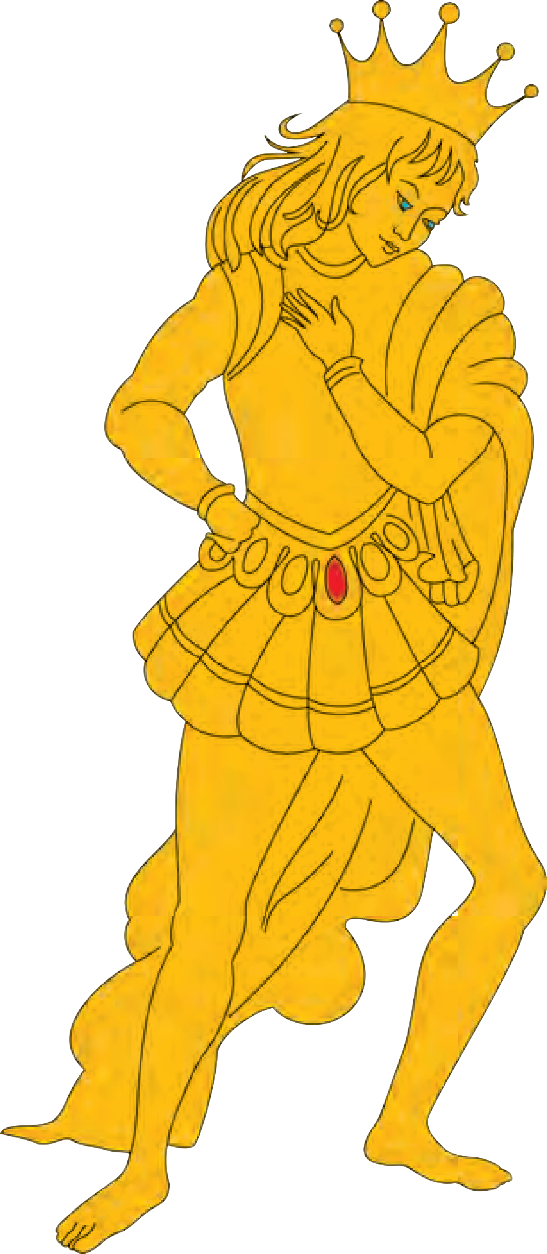

***Why did people admire the statue?***

***What were the drops that fell on the swallow?***

***When did the Happy Prince realize about his suffering people?***

*T*he statue of the Happy Prince stood high above the city. It was covered with gold, its eyes were bright blue jewels, and a red jewel hung from its waist.

Everyone thought that it was very beautiful.

‘Why aren’t you like the Happy Prince?’ mothers said to their little boys when they cried.

Sad men looked at the statue and said, ‘I am glad that someone in the world is happy.’

One night a little Swallow flew alone over the city. His friends had gone away but he had stayed behind for six weeks, ‘Where can I stay tonight?’ he thought. Then he saw the statue. ‘I will stay there,’ he thought. ‘It is high up, so there is plenty of fresh air.’

He landed between the feet of the Happy Prince. ‘I have a golden bedroom!’ he thought. But as he put his head under his wing, a large drop of water fell on him.

He looked up ‘That is very strange!’ he thought.

There is not a cloud in the sky, but it is raining!’

Then another drop fell. ‘I cannot stay on a statue that does not keep me dry,’ he thought. ‘I must find another place.’ And he decided to fly away. But as he opened his wings, a third drop fell. He looked up and saw - Ah! What did he see?

The eyes of the Happy Prince were full of tears. Tears rolled down his golden face. The face was very beautiful in the moonlight, and the Swallow felt sorry for him.

‘Who are you?’ asked the bird. ‘I am the Happy Prince.’

‘Then why are you crying? I am wet with your tears.’

‘When I was alive,’ said the prince, ‘I had a heart like every other man. But I did not know what tears were. I lived in a palace where there was no sadness. In the daytime I played with my friends in a beautiful garden, and in the evening I danced. There was a high wall round the garden. But I did not know what lay on the other side. So I was called the Happy Prince. I was pleased with my little world. Now I am dead, and

they have put me up here. I can see all the unhappiness of my city. My heart now is made of a cheap metal. But even that poor heart can feel, and so I cry.’



***What was the first gift from the Happy Prince?***

***Why was the mother forced to ignore her ailing son?***

***Why had the Swallow felt warm?***

‘Oh,’ said the Swallow to himself, ‘he is not only gold on the outside.’

‘Far away from here,’ said the Happy Prince in a low voice, ‘there is a poor house in a little street. Through an open window, I can see a woman at a table. Her face is very thin and she has rough, red hands. She is making a dress for one of the queen’s ladies, for a dance in the palace. Her little boy is lying on a bed in the corner of the room. He is very ill. He is crying because she can only give him water from the river. Little bird, will you take my red jewel to her? I cannot move from here.’

‘My friends are waiting for me in Egypt,’ said the Swallow.

‘Little bird, little bird,’ said the prince, ‘Please stay! The boy is crying and his mother is so unhappy.’ The Happy Prince looked very sad, and the little

Swallow was sorry for him. ‘It is very cold here,’ he

said ‘but I will stay with you for one night. Tomorrow I will take the jewel.’

‘Thank you, little bird,’ said the prince.

So, the Swallow took the great red jewel from the prince’s waist and flew away with it over the roofs of the town. He passed the palace and heard the sound of dancing.

The bird passed over the river and flew and flew. At last he came to the poor little house and looked inside. The boy was lying on the bed. The mother was asleep; she was so tired. He flew in and put the great red jewel on the table. Then he flew round the bed, moving the air around the boy’s face with his wings.

‘Oh,’ said the boy, my face does not feel so hot.

I think I am getting better.’ And he fell asleep.

Then the Swallow flew back to the Happy Prince. ‘It is strange,’ the Swallow said. ‘It is very cold, but I feel quite warm.’

‘That is because you have done a good thing,’ said the prince. The little Swallow fell asleep.

When day came, the Swallow flew down to the river for a bath. A clever man saw him. ‘That is very

unusual!’ he said. ‘That kind of bird, here in winter!



***What surprised the clever man?***

***Why was the writer unable to complete his story?***

***What did the writer conclude when he saw the blue jewel?***

I must write that down!’

‘I will go to Egypt tonight,’ thought the Swallow. When the moon came up, he flew back to the Happy Prince. ‘Can I do anything for you in Egypt?’

he said.

‘Little bird, little bird,’ said the prince, ‘please will you stay with me for one more night?’

‘My friends are waiting for me,’ answered the bird. ‘Far away across the city’, said the prince, ‘I can

see a young writer in a little room at the top of a

house. He is sitting at a table that is covered with papers. At his side there are some dead flowers. He is trying to finish a story. But he is very cold and he cannot write. There is no fire in the room, and he is weak and hungry.’

‘I will wait with you for one more night,’ said the Swallow kindly. ‘What shall I take to him?’

‘Take him one of my eyes,’ said the prince. ‘They are made of beautiful blue stones. ‘The young man can sell it and buy wood and food. He can finish his story.’

‘Take out your eye, dear prince?’ said the Swallow. ‘I cannot do that!’ And he began to cry.

‘Do it!’ said the prince.

So the Swallow took out the prince’s eye and flew away to the young man’s room. It was easy to get in because there was a hole in the roof. The young man was sitting with his head in his hands, so he did not hear the bird’s wings. When he looked up, a beautiful blue jewel was lying on the dead flowers.

‘Someone likes my stories!’ he cried happily. ‘This is a gift from someone who has read my books, now I can finish writing this story!’

On the next day the Swallow flew down to the river. He watched the seamen working on the ships. ‘I am going to Egypt!’ he cried, but no one listened to him.

When the moon came up, he flew back to the Happy Prince. ‘I have come to say goodbye to you,’ he said.

‘Little bird, little bird,’ said the prince, ‘please will you stay with me for one more night?’

‘It is winter,’ answered the Swallow.’ The snow will soon come. In Egypt the sun is warm and the trees are green. Dear prince, I must leave you; but I will never forget you.’



‘A little girl is standing there in the square below. She is selling eggs. Her eggs have fallen on the ground and they are broken. She has no money to take home. Her father will hit her. Take out my other eye and give it to her.’

‘I will stay with you for one more night,’ said the Swallow, ‘but I cannot take out your other eye. You will not be able to see!’

‘Do it!’ said the prince.

So the Swallow took out the prince’s other eye and flew down with it. He flew to the girl and put the jewel in her hand.

‘This is a beautiful piece of glass!’ cried the little girl. She ran home, laughing.

Then the Swallow flew back to the prince. ‘You cannot see now,’ he said,’ so I will stay with you.’

‘No,’ said the poor prince,’ ‘you must go to Egypt.’ ‘I will stay with you,’ repeated the Swallow, and

he slept at the prince’s feet.

The next day he stayed with the prince. He told the prince stories about the strange lands that he knew. ‘Dear little bird,’ said the prince, ‘you are telling

me about strange and wonderful things, but the suffering

of men and women is stranger than anything. Fly over my city, little bird. Tell me what you see there.’

So the swallow flew over the great city. He saw the poor people sitting at the gate. He flew into the dark streets and saw the white faces of hungry children with sad eyes. Under a bridge, two little boys were lying close together to keep warm. ‘We are so hungry!’ they said. ‘You cannot lie there!’ shouted a guard.

Then the Swallow flew back and told the prince. ‘I am covered with fine gold,’ said the prince.

‘Take it off, piece by piece, and give it to my poor

people.’

The Swallow pulled off the gold, until the Happy Prince looked grey and ugly. The Swallow took the gold to the poor, and the children’s faces became brighter.

***Why did the swallow wish to go to Egypt?***

***Why did the swallow refuse to take off the other eye?***

***What sufferings did the Swallow discover and report to the Happy Prince?***



***In what state did the important man in the city find the statue?***

***What do you think, was the part of statue which did not melt?***

***Why did the servants of God take the broken heart and the dead bird to God?***

‘We have bread now!’ they cried.

Then the snow came. Ice followed the snow, and hung down from the roofs of the houses. Everyone wore thick coats.

The little Swallow became colder. He did not leave the prince, because he loved him very much. But he was dying.

‘Goodbye, dear prince!’ he said.

‘I am glad that you are going to Egypt,’ said the prince. ‘You have stayed too long.

‘I am not going to Egypt,’ said the Swallow. ‘I am going to the House of God’. It fell down dead at his feet. Then there was a strange sound inside the statue. CRACK — the metal heart broke into two pieces.

Early next morning, an important man in the city was walking below with two of his friends. He looked up at the statue.’ The Happy Prince does not look very bright!’ he said. ‘The red stone has disappeared, his eyes are not there, and he is not golden. He looks like a beggar.’

‘Yes he does!’ said the man’s friends.

‘Here is a dead Swallow at his feet!’ said the officer. ‘We must make an order that birds cannot die here.’

They pulled down the statue of the Happy Prince and put it in the fire. A stream of bright metal ran out. ‘This is strange! said the workmen. ‘This broken

piece in the middle of the statue has stayed hard. We

must throw it away.’ So they threw it away with the dead bird.

God said to his servants, ‘Bring me the two best things in the city.’ They brought Him the broken heart and the dead bird.

‘Yes, you have brought the right things,’ God said. ‘This little Swallow will sing for ever in my garden, and the Happy Prince will stand in my city of gold.’

*- Oscar Wilde*



1. **Say whether these sentences are true or false and correct the false ones.**
   1. The writer of the story is William Blake.
   2. Everyone admired the statue of the Happy Prince.
   3. The mother was working, when the Swallow brought the yellow jewel.
   4. The two best things the servants brought to God were gold and jewel stones.
2. **Find from the story the Homophones of the following words**

(Words that sound the same, but differ in spellings and meanings.)

(a) weak (b) their

* + 1. blew (d) sea

(e) read (f) waste

(g) know (h) knot

(i) threw (j) right

1. **Answer the given questions in your own words.**
   1. Where was the Happy Prince’s statue located?
   2. Why did the swallow decide to stay under the statue of the Happy Prince at night?
   3. Why was the Prince sad?
   4. What was the first task given to the Swallow?
   5. To whom did the Prince gift the two gemstones of his eyes?
   6. What decision did the Swallow finally make? Was it a wise one? Comment.
   7. Why did the Swallow finally decide not to leave the Prince ?
   8. What message do you get from this story?
2. **Infinitives, Participles, Gerunds**
   1. **Infinitives**

In the sentences ‘I have to study’ and ‘ I must study’, ‘study’ is in the infinitive form, because it does not take -s, -es or -ed after it even if the number or person of the Subject changes.

Infinitives are generally preceded by ‘to’ or sometimes by a modal auxiliary.

* 1. **Participles**

In the sentences ‘She dived into the swimming pool’ and ‘The writing table is in a mess’ ‘Swimming’ and ‘writing’ are in the verb + ing form and function as Adjectives. These are Present Participles.

In the sentences, ‘The police recovered the stolen jewels’ and ‘He bandaged his bruised arm’, stolen and bruised are in the verb + en / ed form and function as Adjectives.

* 1. **Gerunds**

In the sentences, ‘I love swimming’ and ‘Reading is a good habit’, the verb + ing form fuction as Nouns (as the Subject or Object). These are called Verbal Nouns or Gerunds.

* + - **Say whether the underlined are Infinitives / Participles (Present or Past) / Gerunds.**
      1. I wish to go to Egypt.
      2. They liked his written stories.
      3. He is trying to finish a story.
      4. Suffering is stranger than anything.
      5. The dying swallow fell at his feet.
      6. He began to cry.
      7. He watched the working seamen.

1. **Write the following dialogues from the story in the Indirect Speech.**
   1. ‘Who are you?’ asked the bird. ‘I am the Happy Prince.’ ‘Then why are you crying? I am wet with your tears.’
   2. The Happy Prince looked very sad, and the little Swallow was sorry for him. ‘It is very cold here,’ he said ‘but I will stay with you for one night. Tomorrow I will take the jewel.’

‘Thank you, little bird,’ said the prince.

* 1. ‘Little bird, little bird,’ said the prince, ‘please will you stay with me for one more night?’

‘My friends are waiting for me,’ answered the bird.

* 1. Under a bridge, two little boys were lying close together to keep warm. ‘We are so hungry!’ they said. ‘You cannot lie there!’ shouted a guard.
  2. ‘Goodbye, dear prince!’ he said.

‘I am glad that you are going to Egypt,’ said the prince. ‘You have stayed too long.‘I am not going to Egypt,’ said the Swallow. ‘I am going to the House of God’

1. **Divide the story into parts. Make 4 groups in your class. Each group should take one of the 4 parts to convert the story into a play and enact your part.**
2. **If you could change the end of the story i.e. after the Swallow refused to fly to Egypt, how would you change it? Summarise your idea in 10 to 12 lines.**
3. **Think of one of your favourite stories. Fill in the following facts about the story**.

* Name of the story :
* Type of story :
* Setting (time and place) :
* Important characters :
* Theme / Plot :
* Conflict / Dilemma :
* Solution :
* End :







**WORD PLAY**

**WORD LADDER**

1. **Word Ladder** is a word game.

* Players can get a starting word and an ending word.
* Starting and ending words must be of the same length.
* Players can change one letter at a time, attempting to move from the starting word to the ending word.
* Each intermediate step must be a valid word and no proper nouns allowed ! See the following word chain -
  1. HARD to EASY :hard-hare-care-cart-cast-east-easy
  2. Taking a pig to a sty.

Pig - wig - wag - way - say - sty

**Work in pairs and try to build a ladder.**

* COLD to HEAT • CAT to DOG
* MAN to APE • TEA to POT

**WORD CHAIN**

1. **Word chain :** Word chain is a word game that begins with the letter that the previous word ended with.

**Activity :** Arrange the participants in a circle and explain the rules of the game, any variations and the theme of the word chain.

For example :

Theme : (1) Types of fruit (Noun)

1. Adjectives
2. Verbs
3. in general

**Now prepare a word chain beginning with the given theme and words.**

Theme - School

1. Teacher
2. Verbs
3. Sports and games

**TONGUE TWISTER**

1. **Tongue Twister :** Tongue Twister is a sequence of words or sounds, typically of an alternative kind, that are difficult to pronounce quickly and correctly.

For Example : • Peter piper picked a pack of pickled pepper.

* Saina leads, Sayali needs.
* A big black bear sat on a big black rug.

**Activity :** Use the internet and find out minimum 5 tongue twisters and present them in the class.

1. **Build a Word Pyramid**

Starting with one / two letter-words make word pyramids as shown below, adding one letter at a time for each step. Add as many steps as possible to your pyramid.

You may use a dictionary, if needed.

Make sure the words are meaningful and are not Proper Nouns.

US I

USE IN

MUSE WIN

AMUSE TWIN

TWINE

1. **Express with a Difference!**

A fixed group of words, whose meaning is quite different from that of individual words used in it are called **Idioms**.

For example : • to throw light on ( means to explain clearly in detail)

* within a stone’s throw away (at a short distance)
* a child’s play (very easy)

Make a collection of such Idioms that you come across in storybooks, magazines and other reading material.

Use a good dictionary to find their meanings.

Write them down in a special book or diary. You can refer to it when you do creative writing, to make it impressive.

Also try to use them in your conversation.

1. **Better your Work!**

* Find words which sound the same, but have different spellings and meanings: For example : write and right

They are called **Homophones**.

* Find words which have the same spelling, but can have different pronunciations. For example : ‘read’ can be pronounced as ‘reed’ or as ‘red’.

These are called **Heteronyms.**

* Find words that spell the same, sound the same but have different meanings in different contexts.

For example : light can mean ‘not heavy’. It can also mean ‘brightness which makes things visible’.

Such words are called **Homographs**.

# The Plate of Gold



1. **Stories can be told even in the form of poetry. Such poems are called Narrative poems. Narrative poems do not always follow rhythmic patterns of a fixed rhyme scheme. Such poems are written in a style called ‘Free Verse.’**

**Recall and name some narrative poems you have done / read earlier.**

1. **Read the poem below and fill in the gaps, choosing appropriate pairs of rhyming words, to make them meaningful.**

**Little things**

Little drops of water, Little grains of

Make the mighty ocean

And the pleasant .

Thus the little minutes,

Humble though they , Make the mighty ages

Of .

Little deeds of kindness, Little words of

Make this earth an Eden, Like the heaven a

(love - above / sand-land / be - eternity)

* **What important message does the above poem convey?**

# The Plate of Gold



***Who could claim the plate of gold?***

**loveth best :** (*here*) one who loves God most

**proclamation :** a public statement

**deem :** consider, regard

**adjudge :** consider and declare

**quarter :** (*here*) corner

**renowned :**

well-known

**solemn :** serious **claimants :** those who state the right to get

something

**bestowed :** presented as a gift

***To whom did the priests gift the plate of gold?***

**parted :** distributed

***What magical occurance shocked the people?***

**aghast :** shocked and horrified

**hapless :** unfortunate

**guerdon :** reward

**maimed :** permanently damaged, crippled

One day there fell in great Benares’ temple-court

A wondrous plate of gold, whereon these words were writ; To him who **loveth best,** a gift from Heaven.’

There at

The priests made **proclamation**: ‘At the midday hour,

Each day, let those assemble who for virtue **deem**

their right to Heaven’s gift the best; and we will hear the deeds of mercy done, and so **adjudge**.’

The news

ran swift as light, and soon from every **quarter** came nobles and munshis, hermits, scholars, holy men,

and all **renowned** for gracious or for splendid deeds, Meanwhile the priests in **solemn** council sat and heard what each had done to merit best the gift of Heaven.

So for a year the **claimants** came and went.

At last,

after a patient weighing of the worth of all,

the priests **bestowed** the plate of gold on one who seemed, the largest lover of the race - whose whole estate,

within the year had been **parted** among the poor. This man, all trembling with his joy, advanced to take the golden plate when lo ! at his finger’s first touch

it changed to basest lead ! All stood **aghast**; but when

the **hapless** claimant dropt it clanging on the floor, Heaven’s **guerdon** was again transformed to shining gold.

So far another twelve month sat he priests and judged. Thrice they awarded - trice did Heaven refuse the gift. Meanwhile a host of poor, **maimed** beggars in the street

lay all about the temple gate, in hope to move

that love whereby each claimant hoped to win the gift

and well for them it was (if gold be charity),



***Why had many beggars collected outside the temple?***

***Why did the pilgrims, to the temple, shower coins to the beggars?***

***What did they fail to do?***

**shrivelled :** dried up and wrinkled

**shunned :** avoided and rejected

***What did the poor peasant offer the blind beggar?***

**wrangled :** argued angrily

For every pilgrim to the temple gate praised God, that love might thus approve itself before the test, and so coins rained freely in the outstretched hands;

but none of those who gave, so much as turned to look into the poor sad eyes of them that begged.

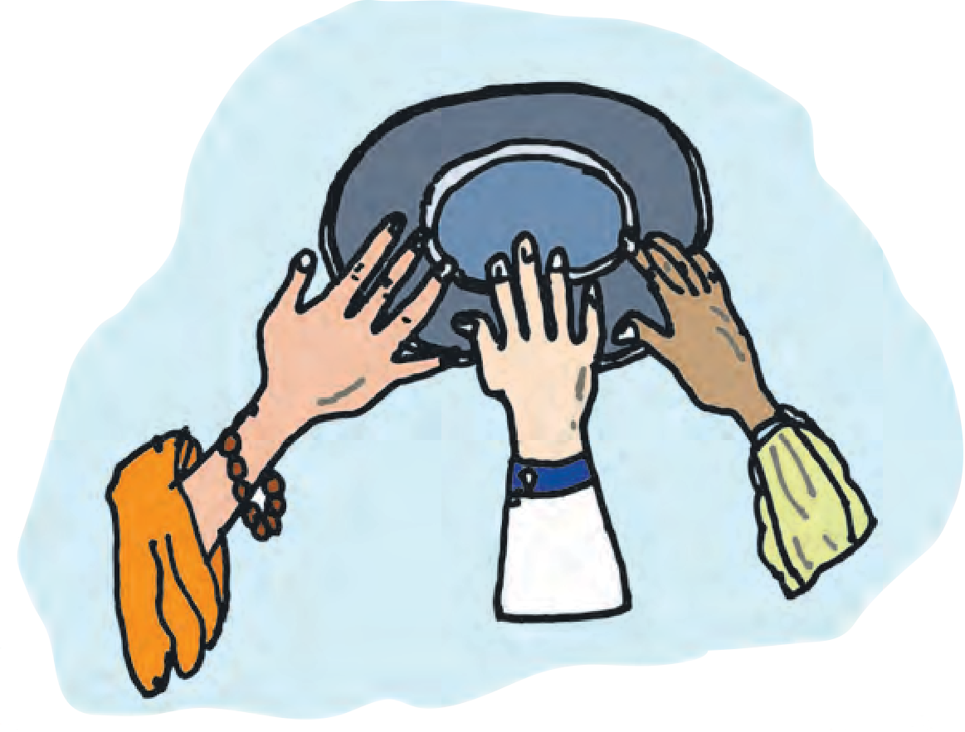

And now

The second year had almost passed, but still the plate of gold , by whomsoever touched was turned to lead. At length there came a simple peasant - not aware of that strange contest for the gift of God-to pay

a vow within the temple. As he passed along

the line of **shrivelled** beggars, all his soul was moved within him to sweet pity, and the tears welled up

and trembled in his eyes.

Now by the temple gate

there lay a poor, sore creature, blind, and **shunned** by all; but when the peasant came, and saw the sightless face and trembling, maimed hands he could not pass, but knelt, and took both palms in his, and softly said: ‘O thou,

my brother! bear thy troubles bravely. God is good.’ Then he arose and walked straightway across the court,

and entered where they **wrangled** of their deeds of love before the priests.

A while he listened sadly then



had turned away but something moved the priest who held the plate of gold to **beckon** to the peasant. So

he came, not understanding and obeyed, and stretched his hand and took the sacred vessel. Lo ! it shone

with thrice its former **lustre**, and amazed them all! ‘Son’, cried the priest, ‘rejoice, the gift of God is thine. Thou lovest best!’ And all made answers, ‘It is well.’

And, one by one, departed. But the peasant knelt and prayed, bowing his head above the golden plate;

while o’er his soul, like morning, streamed the love of

God.

*- James Henry Leigh Hunt*

**beckon :** call

**lustre :** shine

***Why had God chosen the simple peasant as the most deserving of the plate of gold?***



1. **Pick out words from the poem to complete the sentences meaningfully.**
   1. Stephen Hawking was a . (famous) Astrophysicist.
   2. The Government made a (announcement) about their new taxation policy.
   3. Everyone stood (horrified) when the terrible accident took place.
   4. She (bargained) with the hawker to reduce the price.
   5. Handicapped people should never be . (ignored and avoided)
2. **Make a list of archaic words from the poem and give their modern equivalents.**
3. **Rearrange the following in the proper order and insert them into a flow chart as per the poem.**
   1. The plate turned to lead, when it was gifted to false-hearted claimants.
   2. Many claimants donated their wealth to receive the plate of gold.
   3. For almost two years, no claimants received the plate of gold.
   4. A plate of gold fell in a temple from Heaven.
   5. The peasant offered comfort and courage to a blind miserable beggar, whom all had ignored.
   6. The priests announced that the one who loved God most of all, would receive the gift from Heaven.
   7. When the priest gave the plate of gold to that peasant, it shone with thrice its lustre.
   8. A simple peasant, who had nothing to offer, came to that temple.
4. **Which two sayings about God are conveyed through the poem ‘The Plate of Gold’?**
   1. God helps those, who help themselves.
   2. God loves those, who love their fellow beings.
   3. God loves those, who give away their wealth, to please Him.
   4. Service to mankind is service to God.
5. **‘But the peasant bowed and prayed to God** **’ What could he have prayed for ?**
6. **Imagine that you are the peasant. Compose a short prayer to God, after having received the plate of gold. Write it using stylish handwriting.**
7. **Read other poems by Leigh Hunt, especially ‘Abou Ben Adhem’.**

**Compare the messages in that poem with those in ‘The Plate of Gold’. What do you observe ?**





# The Kite Festival



1. **Cut out the wrong kites.**

|  |  |  |  |  |
| --- | --- | --- | --- | --- |
| Nouns  Verbs  Adjectives | festival  festivity  festive | celebration  celebrate  celebrity | traditional  trade  traditional | competition  compete  compere |

1. **Name the festival that you enjoy the most of all. Fill in the facts about that festival.**
   1. Name of the festival :
   2. When it is celebrated :
   3. Why it is celebrated :
   4. How it is celebrated :
   5. Special cuisine :
   6. Other special features :

# The Kite Festival



**harassed :** troubled, stressed out

**come a long way :**

progressed, developed

***How did the kites of the past differ from the modern ones?***

***When is kite-flying at its peak in India?***

***How do they celebrate the***

***kite-flying festival in Gujarat?***

**coincides :** occurs at the same time

*Y*ears ago, the **harassed** mother would often say to her restless son, who needed to be kept busy during his holidays, “Why don’t you go fly a kite ?” And the

little boy would happily pick up his kite and run out into the field.

That, of course, was in the past when the only kites available were made of kite paper and thin wooden frames. Kite - flying has **come a long way** since then with the invention of motorised and even fibreglass kites to compete with the old - fashioned kites. Today, kite - flyers can be found in different parts of the world, carrying different types of kites - waiting for the right winds !

Kite - flying has a long history. There are many Greek, Indian and other mythological stories which tell us about human beings wanting to or trying to fly.

Over a period of time, this desire of humans and their imagination probably led to the invention of kites. And it is likely that the box - kites, designed more than a hundred years ago, later inspired others to create power - driven aeroplanes.

In India, however, the tradition of kite - flying has not changed. Be it during the coming of Spring which is celebrated as Basant or during the festival of Makar Sankranti, people of all ages go out into the open to try their luck with their kites. In towns and cities, where open spaces are difficult to find, terraces and rooftops are often used for this traditional sport.

In Gujarat, Makar Sankranti is kite - flying day. Traditionally celebrated on January 13 or 14, it is a holiday when people meet outdoors, ‘to cut’ each other’s kites.

This day also **coincides** with the festival of Uttarayan, when the sun is said to begin its journey to the northern hemisphere. The people of Gujarat celebrate Uttarayan with a lot of enthusiasm and all business comes to a grinding halt for a couple of days. It is also a celebration to mark the end of winter.

The kite - flying begins at dawn and continues without a pause throughout the day. People of all ages

gather on terraces or rooftops. Friends, neighbours, even total strangers compete with one another and cries of triumph **rend** the air when someone cuts the line of a rival !

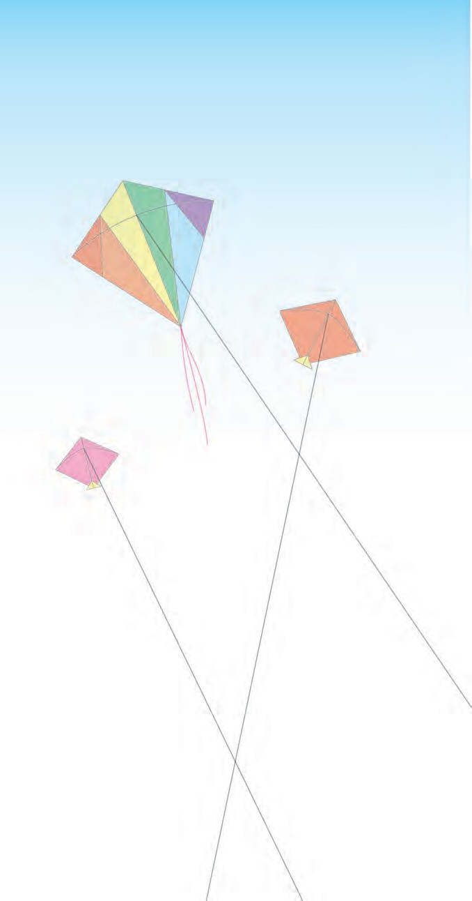

A wonderful variety of kites is seen and the **fussy** buyer can choose what he wants. The more serious players prepare special lines for their kites. There is music in the air and traditional **delicacies** are specially prepared for the day.

Held on the same day, the bigger event, however, is the International Kite Festival, at Ahmedabad. Organised by the Gujarat State Tourism Corporation, it is held either at the Sardar Patel Stadium or the Police Stadium.

This popular festival attracts international kite - flyers, who demonstrate their skills in flying **exotic** kites and local champions as well. Little Indian paper - kites compete with those from Japan, the USA, the UK and other countries. Excited spectators watch in **awe** as marvellous shapes such as eagles and snakes soar into the skies.

One of the highlights of this festival is the Patang or Kite Bazar, in the heart of Ahmedabad, which is open twenty - four hours a day, for a whole week. A visit to this bazar in the middle of the night is enough to prove that the entire city is **obsessed** with kites. People crowd the streets and buy their stocks, **haggling** through the night.

Skilled craftsmen demonstrate age - old kite - making skills and how to prepare the special thread used for kite - flying. Mixtures of glue and ground glass cover the lines, which are dried and rolled onto reels known as ‘*firkees*’. These lines are so sharp that, carelessly used, they can cut a finger !

The excitement does not end with nightfall. Now, it is time for **illuminated** box - kites, often strung on one line, to be launched into the sky. Called *tukals*, they add a grand beauty to the dark sky and compete with the brilliance of the stars.

**rend :** tear

**fussy :** very choosy

**delicacies :** fine, special food items

***Why is the kite-festival at Ahmedabad so special?***

**exotic :** belonging to far-away lands

**awe :** wonder, amazement

***What does a visit to the Patang Bazar prove?***

**obsessed :** totally occupied with one aspect

**haggling :** bargaining

***How is the special thread for kite-flying prepared?***

**illuminated :** lighted up

***What are*** ‘***tukals***’***?***



1. **Give the Antonyms and Synonyms of the words below, choosing from those given.**

**Synonyms**

lustre, rise, victory, competitor, old - fashioned, joyfully, foreign, pause

**Antonyms** partner, dullness, start, sorrowfully, drop, modern, native, defeat

|  |  |  |
| --- | --- | --- |
| **Words** | **Synonyms** | **Antonyms** |
| happily |  |  |
| traditional |  |  |
| halt |  |  |
| triumph |  |  |
| exotic |  |  |
| rival |  |  |
| soar |  |  |
| brilliance |  |  |

1. **Say whether the following statements are true or false.**
   1. Fibreglass kites led to creating power - driven aeroplanes.
   2. In Gujarat, the kite - festival is celebrated to welcome the Spring.
   3. ‘Uttarayana’ starts from Makar Sankranti onwards.
   4. Kite - flying in Gujarat, is a competive sport - cum - festival.
   5. The kite - bazar in Ahmedabad, is open day and night for a week.
   6. The special thread for kite - flying is sharpened by adding sugar and glass pieces.
2. **Using points from the lesson, give the details of the following in a short paragraph for each topic.**
   1. Different types of kites.
   2. International Kite Festival at Ahmedabad.
   3. The kite bazar of Ahmedabad.
3. **You have just returned after your first experience of the kite - festival in Gujarat / Ahmedabad. You were thrilled with the festivities.**

* Write a short report about the kite - festival for your local newspaper. Give an attractive headline, a dateline and an account of the kite - festive. Write the report in the third person with more use of Passive voice.
* You have a friend who lives abroad. Write a letter to your friend describing how you enjoyed the kite-festival.

1. **(A)** Verb forms show both, **Tense** (Present, Past, Future) and **Aspect** (Progressive, Perfect, Perfect Progressive)

**Progressive** (Continuous) : be + verb - ing Present Progressive : He is playing.

Past Progressive : He was playing. Future Progressive : He will be playing.

**Perfect** : have / has / had verb - en / ed Present Perefct : They have played.

Past Perefct : They had played.

Future Perfect : They will have played.

**Perfect Progressive** : have/has/had + been + verb - ing Present Perfect Progressive : We have been playing.

Past Perfect Progressive : We had been playing.

Future Perfect Progressive : We shall have been playing.

1. **Underline the verb forms in the following sentences and state their Tense and Aspect.**
   1. They are waiting for the right winds.
   2. People were haggling over the price of kites.
   3. Vendors had been selling kites all through the week.
   4. Skilled craftsmen had demonstrated age - old skills.
   5. State Tourism Corporation will be organising the International Kite Festival.
   6. Kite - flyers have demonstrated their skills with exotic kites.





# The Last Leaf



1. **Suppose you suffer from a long - term illness (one or two weeks), what should you do and what should you avoid? Fill up the table of Dos and Don’ts.**

|  |  |
| --- | --- |
| **Dos** | **Don’ts** |
| (1) Go to a doctor for diagnosis | (1) Do not |
| (2) | (2) Do not avoid medication on time. |
| (3) Take a suitable diet | (3) Avoid |
| (4) | (4) Avoid physical stress and exertion. |
| (5) Rest in a properly ventilated room. | (5) Do not |
| (6) Have cheerful thoughts, courage, positive attitude. | (6) Do not lose and |

1. **You already know that Homophones are pairs of words that sound the same but differ in spellings and meanings.**

For example : sum and some

There are some words that even have the same spelling and pronunciation but have different meanings in different situations or contexts.

For example : bat (a bird) and bat (sports / games equipment) Such words are called **Homographs**.

* + Make pairs of sentences of your own to point out the different meanings of the following Homographs.

1. fine :
2. wave :
3. bear :
4. rose :
5. lead :
6. match :
7. second :
8. object :

# The Last Leaf



***What dreadful illness did Johnsy suffer from?***

***What did the doctor tell Sue about Johnsy?***

**ivy vine :** a strong creeper with green leaves and yellow berries

**gnarled :** (here) twisted

***Describe the ivy vine outside the window.***

*I*n the poorer parts of New York, there was a colony where many struggling artists lived. Among them were

Sue and Johnsy. They had come to New York from different parts of the United States. When they met, they found that they shared the same interest, and they became friends. They shared a flat and set up a joint ‘studio’ trying to earn a living through art.

Johnsy was small, thin and not very strong. After spending a few months in New York, she became ill with pneumonia. In those days, it was not easy to cure pneumonia patients. Though Sue looked after her well, Johnsy showed no signs of improvement.

One day, the doctor told Sue that Johnsy had one

chance in ten. “And that chance is for her to want to live,” he said. “Your little lady has made up her mind that she’s not going to get well.” He told Sue that medicines alone did not help if the patient did not wish to live.

That day, Johnsy just lay in bed without making any sound or movement. First, Sue thought that she had fallen asleep but then she noticed that Johnsy was looking out of the window and was counting something again and again in a very low voice - almost a whisper.

Sue, too, looked out of the window, but there was nothing to see - only an old, old **ivy vine**, **gnarled** and decayed at the roots, climbed half way up the brick wall. The cold breath of autumn had taken away most of the leaves. Only the skeleton branches were left, clinging to the bricks.

“What is it, dear ?” asked Sue.

“Six,” said Johnsy. “They are falling faster now . Three days ago, there were almost a hundred.



***What false belief did Johnsy have about the ivy vine?***

**broth :** a hot soup

***Who was Behrman? Why did Sue call him to their flat?***

**wielded the brush**

**:** painted with a flourish

**masterpiece :** a most valuable, outstanding work of art

**fancy :** imagination

It made my head ache to count them. But now it’s easy.

There goes another one. There are only five left now.” “Five what, dear ?”

“Leaves. On the ivy vine. When the last one falls, I must go, too. I’ve known that for three days. Didn’t the doctor tell you?’’

“Oh, I never heard of such nonsense,” said Sue. “What have old ivy leaves to do with your getting well ? And you used to love that vine so ! Don’t be silly. The doctor said that you had excellent chances of getting well. Take some **broth** now, and let me get back to my work.”

But Johnsy just kept looking out of the window. “There goes another. No, I don’t want any broth. That leaves just four. I want to see the last one fall before it gets dark. Then I’ll go, too.”

“Johnsy,” said Sue, “will you promise me to keep your eyes closed and not look out of the window until I am done working? I must hand those drawings in tomorrow. I need the light. Otherwise I would have closed the window. I don’t want you to keep looking at those silly ivy leaves.”

“Tell me as soon as you have finished,” said Johnsy, closing her eyes, “because I want to see the last one fall.”

“Try to sleep,” said Sue. “I must call Behrman up to be my model for the old man that I’m drawing. I’ll not be gone a minute.”

Old Behrman was a painter who lived on the ground floor, but he was a failure in art. For forty years he had **wielded the brush** but had not made any money. He had been always about to paint a **masterpiece**, but had never yet begun it. For several years, he had only made a few paintings. He earned a little by serving as a model to the young artists in the colony, who could not affored other models. He always talked of his coming masterpiece.

Sue told Behrman about Johnsy’s **fancy**. Old Behrman was shocked that anyone could have such idiotic ‘imaginings’. “What!” he cried. “Are there people in the

world foolish enough to die because of leaves dropping off

from a vine ? I have not heard of such a thing. Why did you allow this thought to enter her brain?”



***What did Behrman promise to do some day?***

**mingled :** mixed

***What happened that night and what did the two friends see when the window was open?***

**tinted :** slightly coloured

***What did Johnsy declare when she***

***saw the last ivy leaf?***

**twilight :** soon after sunset but before it is dark

“She is very ill and weak,” said Sue. “The fever has made her mind full of fancies.”

“This place is not good for Miss Johnsy. Some day I’ll paint a masterpiece and we shall all go away. Yes !” said Behrman.

Johnsy was sleeping when the two went upstairs. Sue showed Behrman the ivy vine that Johnsy saw through the window. They looked at each other for a moment without speaking, and then began their work. Outside a cold rain was falling continuously, **mingled** with snow. Sue closed the window.

Next morning, when Sue woke up, she found that Johnsy was staring at the closed window again with dull, wide-open eyes.

“Open the window ; I want to see,” she ordered. Sue obeyed.

But, lo ! even after the rain and the fierce wind that blew throughout the night, there yet stood against the brick

wall one ivy leaf. It was the last on the vine. Still dark green near its stem, but with its edges **tinted** with yellow, it hung bravely from a branch some twenty feet above the ground.

“It is the last one”, said Johnsy. “I thought it would surely fall during the night. I heard the wind. It will fall today and I shall die at the same time.”

Johnsy was preparing herself for the last journey that one makes alone.The feeling was very strong within her.

The ties of Sue’s friendship and other things on earth became loose one by one.

The day wore away but even through the **twilight**, they could see the lone ivy leaf clinging to its stem against the wall. At night, again the wind raged and the rain poured.

Next day, when it was light enough, Johnsy asked Sue

to open the window.

The ivy leaf was still there.

Johnsy lay for a long time looking at it. Then she called Sue. “Sue dear,” she said, “I’ve been a bad girl. Something has made a last leaf stay there to show me how wicked I was. It is a sin to want to die.”

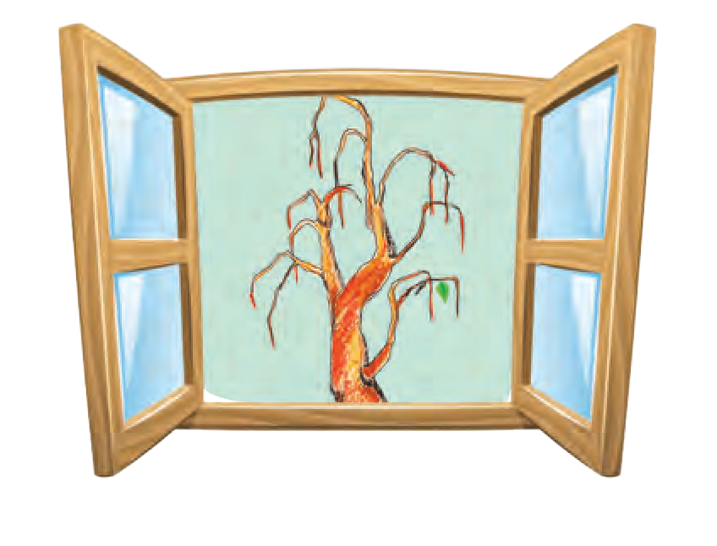

***What change came over Johnsy the next day? Why?***

***What happened to Mr. Behrman?***

**fluttered :** irregular shaking movement

***Who had saved Johnsy’s life and how?***

After that she was ready to take the broth and milk that Sue brought her. She wanted to sit up in bed . ‘‘Someday I hope to paint the Bay of Naples.’’

Mr Behrman downstairs was now ill with pneumonia. The sweeper had found him lying helpless in his room in very wet clothes and shoes. He also found some scattered brushes and a palette with green and yellow colours mixed on it. Two days later, Mr. Behrman died in a hospital.

The last ivy leaf was still there on the wall. It never **fluttered** or moved when the wind blew. It was Behrman’s masterpiece. He had painted it there that night when the last leaf had fallen.

- *Adapted from ‘The Last Leaf’ by O. Henry*



1. **Read the story and choose the appropriate meanings.**
   1. Struggling artists
      1. artists fighting with one another
      2. artists trying hard to earn a living
      3. artists painting war scenes
   2. Skeleton branches
      1. bones branching out from joints
      2. leafy branches
      3. bare branches
   3. Wielded the brush
      1. painted skillfully
      2. broke the brush
      3. joined the broken brush
   4. Palette
      1. the tip of the brush
      2. a board used by artists to mix colours
      3. a fancy dinner plate
   5. Masterpiece
      1. a master who promotes peace
      2. the very first creation of an artist
      3. an exceptionally beautiful work of art
2. **Make pairs of sentences to show the difference between the meanings of the following Homographs from the story.**



* 1. interest
  2. well
  3. left
  4. just
  5. mind



1. **State the facts about the story.**

* Main characters :
* Problem :
* Attempts made to solve it :
* Climax / Turning point :
* Problem solved :
* End :

1. **Say whether the following statements are right or wrong.**
   1. Sue and Johnsy were very close friends.
   2. Sue was a rich girl.
   3. Johnsy was hopeful that she will live.
   4. Behrman was a hard - hearted person.
   5. The last leaf fell off during the rain.
   6. Johnsy realised that her thinking was wrong.
   7. Behrman did not know anything about the last leaf on the ivy.
2. **Correct the following statements.**
   1. Sue and Johnsy were good neighbours.
   2. Johnsy was eager to recover from her illness.
   3. Sue ignored Johnsy completely.
   4. Behrman was a very heartless person.
   5. The real ivy leaf did not fall off at all.
   6. The last leaf was a real leaf that survived.
3. **Read the descriptions of the following from the story and describe any one of them using your own words.**

* The ivy vine  Behrman  The last leaf that Johnsy saw

1. **You have learnt that a Clause is a group of words that has a Subject and a Verb, and is a part of a larger sentence.**

In the sentence, ‘We returned home, when school was over’ there are two clauses.

*(i) ‘We returned home* and *(ii) ‘When school was over’.*

The first one makes complete sense, so it is called **Main / Principal Clause**. The second one is not complete by itself. It depends on the **Main Clause** to convey proper sense. So it is called **Dependant** or **Subordinate Clause**. ‘When’ is the joining word, and it is called a **Subordinator.**

* In the following sentences, point out the Main Clause and Subordinate Clause. Encircle the Subordinator.
  1. There was a colony, where many struggling artists lived.
  2. Though Sue looked after her well, Johnsy showed no signs of improvement.
  3. Sue thought that she had fallen asleep.
  4. Old Behrman was a painter, who lived on the ground floor.
  5. Johnsy was sleeping, when the two went upstairs.
  6. I want to see the last one before it falls.

1. **Compose an imaginary dialogue between Sue and Johnsy, when they realise about what Behrman had done for Johnsy.**

# Leisure



1. **Discuss in groups and share with one another.**
   1. The daily routine of your mother and father on working days
   2. How your family relaxes on weekends
   3. When you go for a picnic, what and how do you enjoy?
   4. Do you spend time admiring and thinking over the beauties of nature ? Elaborate your response.
2. **When a poet / writer attempts to describe something in words, so that it appeals to our five senses (sight, smell, hearing, touch, taste) he / she has used a device called Imagery.**

For example : ‘a host of golden daffodils’.

‘to a chasm, deep and vast and wide’.

**Go through other poems in your textbook or other books and find out lines that contain Imagery. Write them down along with the name of the poem and line / stanza number.**

1. **Prepare an Acrostic from the word ‘Leisure’. The words should be related to what one likes to do in free time.**

**L E I S U**

**R**eading stories

**E**

**Leisure**



**care :** (*here)* worries,

stress

**boughs :** branches of a tree

***What does the poet want us to stare at and gain from it?***

**beauty :** a beautiful young girl

***List the beautiful things in nature that we overlook.***

What is this life if, full of **care**,

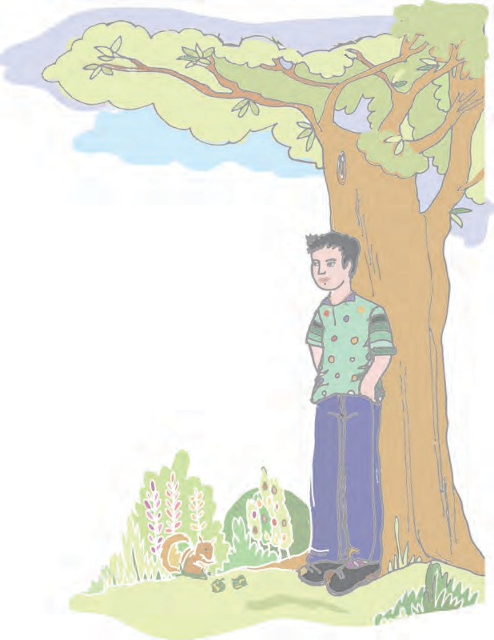

We have no time to stand and stare ?

No time to stand beneath the **boughs**

And stare as long as sheep or cows ?

No time to see, when woods we pass Where squirrels hide their nuts in grass ?

No time to see, in broad daylight, Streams full of stars, like skies at night ?

No time to turn at **Beauty’s** glance,

And watch her feet, how they can dance ?

No time to wait till her mouth can Enrich that smile her eyes began ?

A poor life this if, full of care,

We have no time to stand and stare.

*- William Henry Davies*

1. **Say where . . . . . . .**
2. do the cows and sheep stand?
3. do squirrels store their food?
4. do stars shine in the daytime?
5. does Beauty’s smile begin?
6. **Think and answer in your own words.**
   1. What could have inspired the poet to compose this poem? Do you think it relates to our present day life? Defend your choice.
   2. Which line proves that in our busy lives we do not even have a fraction of a second to enjoy nature’s beauty?
   3. ‘Beauty’ in stanza 5 to 6 can refer to a beautiful maiden as well as nature itself. Explain when and how nature ‘dances’ and also ‘smiles’.
   4. Why does the poet call our life ‘poor’?
7. **​You have learnt that when a human attribute is given to anything that is not a human being or it is spoken of as a person, the Figure of Speech used is called ‘Personification’.**
   1. Pick out two examples of Personification from the poem.
   2. Pick out from the poem, two examples of each of the following Figures of Speech.

(1) Alliteration (2) Simile (3) Metaphor

* 1. The poet opens his poem with a question. Is the question asked to receive some answer? No. It is a question used to emphasize and stress upon the fact that modern man has no time to enrich his life from nature.

Such a device used by poets falls under the Figure of Speech called ‘**Interrogation**’ or ‘**Rhetorial Question**’. Refer to the poem ‘The Pilgrim’ and find examples of Interrogation.

1. **Say where the images from nature given in the poem exist.**

AIR / LAND / WATER

* 1. beneath the boughs
  2. squirrel hide nuts in grass
  3. streams in daytime
  4. stars / skies at night

1. **Make a paraphrase of the poem ‘Leisure’ in your own simple words. Write it down in your notebook.**









**4.1 The Vet**

1. Where do we find all types of wild animals in urban areas?
2. Do you have a pet?
3. How do we help animals and birds?
4. How do we realise that animals are not feeling well?
5. Who gives medicine / treatment to sick animals and birds?
   1. **The doctors who do special advanced study of specific parts of the body have special terms.**

In your group try to match the specialist doctors with who / what they treat.

|  |  |  |  |
| --- | --- | --- | --- |
|  | **Specialists** |  | **Who/What they treat** |
| 1. | Dentist | a. | bones |
| 2. | Cardiologist | b. | brain/nervous system |
| 3. | Opthalmalogist | c. | small kids |
| 4. | Orthopedic | d. | teeth |
| 5. | Pediatrician | e. | animals / birds |
| 6. | Neurologist | f. | eyes |
| 7. | Veterinarian | g. | heart |

(1) (2) (3) (4) (5) (6) (7)

* 1. **Discuss in your group and write down the most important reason, why Pediatrician and Veterinarians have, a tougher job to diagnose their patients’ illnesses.**

# The Vet



**vet :** short form of veterinarian - a doctor for animals and birds

**competent :** having

very good knowledge and ability

***Why is it so difficult to be a successful* vet?**

**exceedingly :** very much

**a different inside :** different types of size of organs inside the body

**groan:** make a sound of pain

***What is wrong with ducks and chickens?***

**incredible :**

unbelievable

**centipede :** a small, long thin creature with many legs

**bison :** American buffalo

***What opposite health problems do the lion and the Arctic fox suffer from?***

**virulent :** caused by virus

**stirred :** moved

**a tiff :** a quarrel

***Why have the giraffes got stiff necks?***



To be a successful and **competent vet**, Needs knowledge **exceedingly** wide,

For each of the patients he’s likely to get Possesses **a different inside**.

He must know why the cat is refusing her milk, Why the dog is not eating his bone,

Why the coat of the horse is not shining like silk,

Why the parrot does nothing but **groan**;

Why the ducks and the chickens are failing to lay,

Why so faint the canary bird sings,

And if he is called to the zoo, he must say An **incredible** number of things.

If the lion’s caught a cold, If the zebra’s getting old,

If the **centipede** has trouble with his feet, If the hippo’s feeling ill,

If the **bison’s** got a chill,

If the Arctic fox is suffering from heat,

If some **virulent** disease

Has attacked the chimpanzees,

If the tortoise hasn’t **stirred** for several years, If the bear’s too full of buns,

If the cobra eats her sons,

If the panther has a wife who chews his ears;

If giraffes have had **a tiff**

And their necks are feeling stiff

**keepers’ :** zoo keepers

***Why does the poet call the vet* ‘*omniscient*’*?***

**cannibal :** one who eats human flesh

**omniscient :** one who knows all and everything

**Profoundly :**

greatly, deeply

***What is the poet*’*s advice to you?***

***Do you think he means it?***

If hyenas will not laugh at **keepers’** jokes, If the monkey’s pinched his tail,

If the rhino’s looking pale,



If the elephant eats paper-bags and chokes, If the camel hurts his hump,

If the kangaroo won’t jump,

If the crocodile turns **cannibal** and bites, They run away and get

That **omniscient**, the vet

And expect him to put everything to rights.

**Profoundly** I pity the vet, who must learn Such a very great deal for his pay;

My son, I advise you most strongly to earn Your living an easier way.

Don’t attempt to attend the zoological crowd; a far more advisable plan

Is to call yourself ‘Doctor’, and so be allowed To treat the illnesses of man.

*- Guy Boas*

**

1. **What is the Rhyme scheme of stanzas 1 to 3 and the last two stanzas? How does it differ in the remaining stanzas, 4 to 7?**
2. **Write any five illnesses of the animals in the poem that you find most amusing / laughable.**

(a)

(b)

(c)

(d)

(e)

* 1. **(A) Out of all names of birds and animals given in the poem, pick out 4 names that are similar in English as well as in Hindi / Marathi or your mother tongue.**

**(B) Write four reasons why animals in a zoo suffer more than those who live free in the wild.**

(i)

(ii)

(iii)

(iv)

* 1. **Think deeply and write. Is the poet really discouraging the youth from becoming vets? Explain your response.**
  2. **Find out from a vet or from a website, what precautions a vet has to take, when he / she is called to treat wild, dangerous animals?**

**Make point-wise notes of the same.**

* 1. **Select any four zoo animals mentioned in the poem. Imagine that they are able to talk in English. Compose a dialogue among the four animals discussing their discomfort and illnesses.**





# Revolutionary Steps in Surgery



1. **Discuss in your class.**
   1. Do you like to study science?
   2. What are the advantages of learning science?
   3. Are robots truly useful to human beings? Why? Why not?
   4. How can we take help of robots in our daily life?
   5. Name some gadgets and appliances that we use in day-to-day life.
2. **Imagine that one of your family members / friends / classmates has recently undergone a surgery. You were curious and wanted to learn about his/her experience.**

Match the questions you asked with their answers.

|  |  |  |  |  |  |  |
| --- | --- | --- | --- | --- | --- | --- |
| 1. | What health problem did you suffer from? | | | a. | I was given a bath and I wore a surgical gown. | |
| 2. | Whom did you inform about it first? | | | b. | I was given an injection of anaesthesia. | |
| 3. | What type of doctor did you consult? | | | c. | I | consulted an orthopedic surgeon. |
| 4 | How did he / she find out that you needed a surgery? | | | d. | I was relieved and happy that the operation was over. | |
| 5. | What preparation before the surgery? | was | done | e. | I had fractured my ankle while playing hockey. | |
| 6. | What did you feel when you were taken to the operation theatre? | | | f. | No, I did not feel anything. I was fast asleep. | |
| 7. | What was the first step before the actual surgery? | | | g. | I recovered and I could walk normally after 3 weeks. | |
| 8. | Did you feel any pain during the surgery? | | | h. | Our school hockey coach | |
| 9. | What did you feel when you opened your eyes after the operation? | | | i. | The doctor took an X-ray of my ankle, and he found a fracture in my ankle. | |
| 10. | How soon did you recover? | | | j. | I | was very nervous. |

1. **We have learnt that sentences may have two, three or more sets of subject**

**+ predicate, joined by a conjunction. Each set of subject and predicate that is a part of a larger sentence is called a clause.**

Separate the clauses in the following sentences and write the conjunction.

* 1. The thief stole the money and he ran away. Clause (1)

Clause (2) Conjunction :

* 1. She told me that she was a doctor. Clause (1)

Clause (2) Conjunction :

* 1. He ran fast but he did not win the race. Clause (1)

Clause (2) Conjunction :

* 1. The traveller arrived at the station after the train had left. Clause (1)

Clause (2) Conjunction :

1. **Coordination**

**Observe the clauses in the following sentences.**

* 1. He is intelligent and he is hardworking.
  2. Asit was tired but he could not rest.
  3. You can go for a walk or you can exercise at home.
  4. Seema has recovered from fever, so she can attend school.

Each of the above sentences has clauses that do not depend on each other for complete sense. They are called Independant or Co-ordinate clauses. They are joined by conjunctions like *and, but, or, so.* Such conjunctions are called **Co-ordinators**.

Other Co-ordinators are :  as well as / not only. but also

* + - yet / still / however / nevertheless
    - or / nor / else / either..... or / neither nor
    - so / therefore / thus / hence / for
    - **From the sentences given in Activity 2 pick out two sentences having Co-ordinate Clauses. Point out the Co-ordinators.**

# Revolutionary Steps in Surgery



**revolutionary :** causing a total dramatic change

**bloodletting :**

draining out blood

***Why did doctors begin to use anaesthesia?***

**anaesthetics :** substances / gases that make one feel no pain

**benumbs :** makes numb so that one does not feel

any pain

**cardiac :** relating to the heart

***Why had cardiac surgery not developed?***

**essential :** necessary

**sedatives :** substances that make someone sleepy

***What had the patient James Cornish suffered from?***

Surgery dates back to as early as 600 BC. ‘Sushruta Samhita’ is one of the oldest works in the world dealing with surgery. It indicates that Sushruta

was probably the first surgeon to perform surgical operations (plastic surgery). Later, some ancient surgeons performed tooth extraction and **bloodletting**.

Major surgery could not develop for centuries because of lack of knowledge and technology. The doctors had to cut open the part of the body that was not healthy, remove it or set right that part. This would involve a lot of pain to the patient. General **anaesthetics** like ether or chloroform developed only from mid - nineteenth century making painless surgical operations possible and successful.

Modern techniques are used nowadays for anaesthesia. General anaesthesia **benumbs** the whole body, and it is used for surgery of any region of the body. For local anaesthesia, local anaesthetics are injected into the surgical spot or an area near nerves.

Over the years now, revolutionary steps have been taken in different types of complicated surgery and these have made such operations successful.

Let us start with **Cardiac** surgery. Today, if you need to have a heart surgery, you can choose from many fine doctors. However, before 1893 this type of surgery was unknown. Doctors did not have modern medical tools and procedures, **essential** for heart surgery. In those days heart patients were treated with **sedatives** and they usually did not survive. Then in 1893 Daniel Hale Williams, a young African American surgeon, attempted a new medical technique in order to save a patient’s life.

A patient, James Cornish, was suffering from a very serious knife wound. The knife had cut an artery less than an inch from his heart and punctured the pericardium (the sack around the heart). Dr Williams with six staff doctors, performed a complicated and daring operation. Dr Williams became the first surgeon to save his patient by successfully repairing the human heart.

Now many more advanced techniques are used to in this speciality, to deal with heart complications. Open heart surgery, which can help to repair heart defects, heart **valves** or even replace them, is also performed successfully. With proper measures, patients can recover from cardiac surgery faster than they did before.



***What kind of cardiac surgery is done nowadays?***

**valves :** devices for allowing flow in one direction only **Neurosurgery :** surgical specialization that treats diseases and disorders of the brain and spinal

cord

**disorders :** (*here*) health defects

***Who do neurosurgeons operate upon and on what body parts?***

**dramatically :** suddenly and successfully

**mortality :** death rate, especially on a large scale

**tumour :** abnormal, extra growth

**stem :** control

**cutting edges :** latest development

**Robotic Surgery:** surgery carried by minimum surgical instruments

**incisions :** surgical cut made in skin or flesh

**miniaturized :** made very small in size **mounted :** set up

**precision :** accuracy **magnified :** enlarged ***What is Da Vinci?***

**a console :** a

combination of display, input devices and control mechanism used for controlling a robot

**Neurosurgery** is another recent speciality to have received recognition since the early 1900s. It is concerned with the treatment of **disorders** of the nervous system.

Neurosurgeons operate on the brain, the spine or nerves. They can treat patients of all ages, from the new-born to the elderly, who have suffered a stroke.

Harvey Cushing (1869-1939) is considered to be the father of modern neurological surgery. In the early part of the 20th Century, he developed basic techniques and instruments for operating on the brain as a distinct surgical speciality. Cushing **dramatically** reduced the **mortality** rate for neurosurgery from 90% to less than 10%. By the time of his retirement in 1937, he had successfully removed more than 2000 **tumours**.

The main reason that mortality rates had been so high before, was blood loss. Among Cushing’s significant achievements are the methods he developed to **stem** this blood loss by inventing a clip called ‘silver clip’ or ‘Cushing clip’.

Thus neurosurgery is one the most **cutting edges**

in the world of surgery and medicine.

What is **Robotic Surgery?**

Robotic surgery is a type of minimally invasive surgery. ‘‘Minimally invasive’’ means that instead of operating on patients through large **incisions**, use is made of **miniaturized** surgical instruments, that fit through a series of quarter-inch incisions. When performing surgery with the Da Vinci, - the world’s most advanced surgical robot - these miniaturized instruments are **mounted** on three separate robotic arms, allowing the surgeon maximum range of motion and **precision**. The Da Vinci’s fourth arm contains a **magnified** high-definition 3-D camera that guides the surgeon during the procedure.

The surgeon controls these instruments and the camera from **a console**, located in the operating room. Placing his fingers into the master controls, he is able

**replicated :** made an exact copy of

***What are the advantages of Robotic Surgery?***

to operate all four arms of the Da Vinci. While looking through a stereoscopic high definition monitor, the robot literally places the surgeon inside the patient. This gives him a better, more detailed 3-D view of the operating site, than the surgeon’s eye can provide. Every movement he makes with the master controls is **replicated** accurately by the robot. When necessary, the surgeon can even change the scale of the robot’s movement. If he selects a three-to-one scale, the tip of the robot's arms will move just one inch for every three inches, that surgeon’s hand moves.

Utilizing this advanced technology our surgeons are able to perform a growing number of complex surgical procedures. Since these procedures can now be performed through very small incisions, our patients experience a number of benefits compared to the open surgery of the past.





1. **Read the lesson and name the following.**
   1. The first surgeon to perform operations
   2. Anaesthetics used from mid 19th century
   3. The first successful Cardiac Surgeon
   4. A sack around the heart
   5. The father of modern neurosurgery
   6. The world’s most advanced surgical robot
2. **Match the terms in ‘A’ with their explanation in ‘B’. ‘A’ ‘B’**
3. tooth- extraction (a) a cut made for surgery
4. cardiac (b) having length, breadth and depth
5. sedative (c) plastic surgery
6. tumour (d) related to the heart
7. incision (e) a control unit for a robotic surgery
8. a console (f) removing a decayed tooth
9. 3-D (g) substance that makes a person sleep
10. Cushing clip (h) an extra growth in the body
    1. a device to stop blood loss in neurosurgery

(1) (2) (3) (4)

(5) (6) (7) (8)

1. **Fill in the web with words related to ‘Surgery’.**



Major

**Surgery**

1. **Write 3 to 4 lines about each of the following in your own words.**
   1. ‘Sushruta Samhita’
   2. First Cardiac Surgery
   3. First Neurosurgeon
   4. The Robotic Surgery
2. **(A) Fill in the gaps in the table of Degrees of Comparison.**

|  |  |  |  |
| --- | --- | --- | --- |
|  | **Positive** | **Comparative** | **Superlative** |
| (1) |  |  | oldest |
| (2) |  | healthier |  |
| (3) | near |  |  |
| (4) |  | finer |  |
| (5) |  |  | earliest |
| (6) | small |  |  |
| (7) |  | faster |  |
| (8) | high |  |  |

1. **Adjectives that have more than two syllables (long words) take ‘more’ and ‘most’ before them to form Comparative and Superlative degrees.**

For example : successful - Positive Degree

more successful - Comparative Degree most successful - Superlative Degree

* + **Give the Comparative and Superlative forms of -**

**Positive Comparative Superlative**

1. ancient
2. special
3. significant
4. advanced
5. accurate
6. **Join the sentences using appropriate Co-ordinators. (but, or, so, and)**
   1. There was lack of technology. Major surgery could not develop for centuries.
   2. Cardiac Surgery was tried in the past. Patients did not survive.
   3. He places his fingers into the master controls. He operates all four arms of the Da vinci.
   4. Open heart surgery can help to repair heart valves. It can also replce them.
   5. Heart patients were treated with sedatives. They did not survive.
   6. These procedures can be performed through very small incisions. Our patients experience a number of benefits.
7. **Write in your notebook an imaginary telephonic conversation between you and your family doctor’s secretary, asking for an appointment to consult the doctor for a health problem you are suffering from. Begin with ..........**

**Secretary :** Good morning ! This is XYZ Clinic.

How can I help you?

**Myself :** Good morning ! I am

*(Now continue. )*

**



**

# The Bees



1. **Match the professions with the field of work.**

**Profession Field of work**

* 1. Chief Minister (a) Business
  2. Magistrate (b) Transport
  3. Soldier (c) Construction
  4. Trader (d) Administration
  5. Builder (e) Education
  6. Driver (f) Defence
  7. Teacher (g) Law

1. **Living creatures, birds, animals, insects, etc. are often used in ‘as - as’ comparisons, because of some special characteristics they hold.**

**Fill in the gaps, choosing words from the brackets to make appropriate comparisons.**

(tall / quiet / humble / merry / busy / slippery / fast / sly / slow / big)

* 1. as as a lark (6) as as a mouse
  2. as as a snail (7) as as an eel
  3. as as a giraffe (8) as as a fox
  4. as as a bee (9) as as a worm
  5. as as an elephant (10) as as a deer

# The Bees



***What do honey bees teach us?***

**sorts :** of different activities

**magistrates :** civil officers who administer the law

**venture :** (here) take up a new project involving a risk

**make boot upon :** begin to collect around

**pillage :** loot

***Where does the emperor - bee sit and what does he do?***

**busied :** very engrossed

**kneading :** mixing uniformly

***What do roofs of gold refer to?***

**surly :** bad-tempered

**delivering :** handing over

**executors :** persons who carry out a death sentence

**drone :** a male bee

So work the honey- bees, creatures that by a rule in nature teach

The art of order to a peopled kingdom, They have a king and officers of **sorts**;

Where some, like **magistrates**, correct at home; Others, like merchants, **venture** trade abroad; Others, like soldiers, armed in their stings; **Make boot upon** the summer’s velvet buds;

Which **pillage** they with merry march bring home To the tent royal of their emperor ;

Who, **busied** in his magesty, surveys,

The singing masons building roofs of gold, The civil citizens **kneading** up the honey, The poor mechanic porters crowding in Their heavy burdens at his narrowgate, The sad eyed Justice, with his **surly** hum, **Delivering** over to **executors** pale

The lazy yawning **drone**

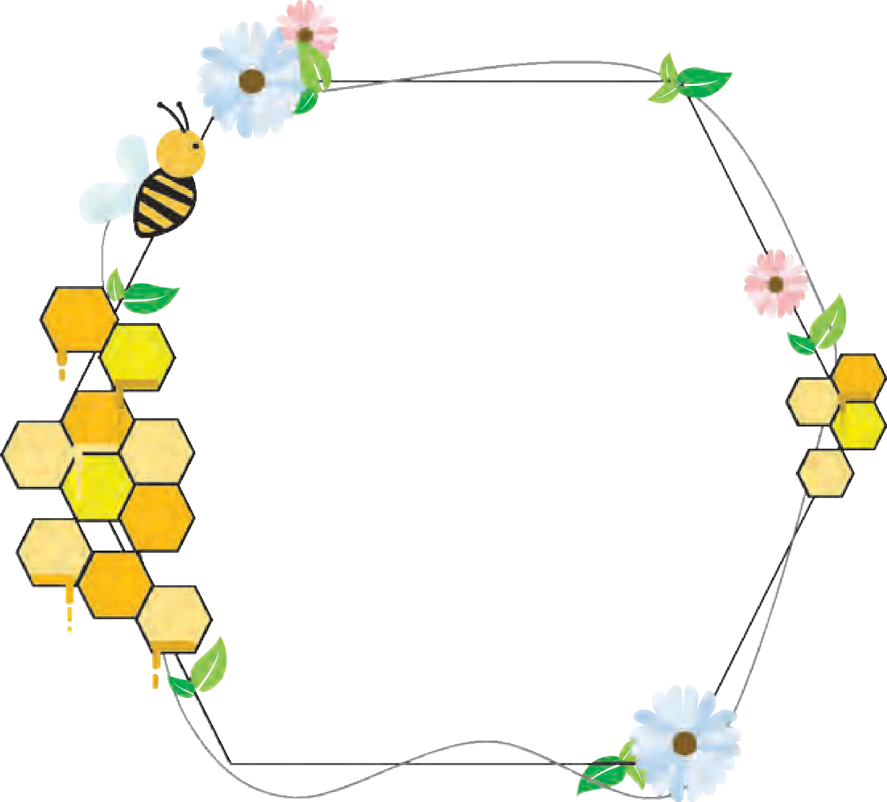- *William Shakespeare*



1. **Honey-bees live an organised life like human beings. Discuss what work the following honey-bees do, as per the poem. Write it down in your own words in your notebook.**
   1. King / Emperor bee (e) Mason bees
   2. Magistrate bees (f) Civilian bees
   3. Merchant bees (g) Porter bees
   4. Soldier bees (h) Judge bee
2. **Complete the following choosing the appropriate option.**
   1. Human beings can learn from honey bees .........

(i) how too make food (ii) how to live joyfully

(iii) how to lead an organised nation.

* 1. The soldier-bees carry home .............

(i) the velvet buds (ii) nectar looted from flowers

(iii) their weapons.

* 1. The emperor-bee supervises the building of ............

(i) the bee hive (ii) bridges (iii) a tower.

* 1. The bees make honey from nectar.

(i) officer (ii) civilian citizen (iii) magistrate

* 1. The drone is given a death sentence because he ........

(i) attacked the emperor (ii) killed other bees

(iii) does not do any work.

1. **(A) Complete the phrases using words from the poem.**
2. ......... march (iv) porters
3. ......... tent (v) burdens
4. ..... masons (vi) executors
5. (i) Find any two Alliterative lines.

(ii) Pick out the line that contains an Onomatopoetic word.

1. **Pick out three lines that create an image in your mind of bees busy at work.**
2. **(A) Refer to a good dictionary that carries phonetic transcriptions printed next to words. The words below are familiar to you. Copy their phonetic transcriptions from the dictionary and say them aloud as you write. (You may take your teacher’s help, if needed.)**

|  |  |  |
| --- | --- | --- |
| (1) work ........ | (4) home ........ | (7) porters ........ |
| (2) bees ........ | (5) mason ....... |  |
| (3) boot ........ | (6) citizen ........... |  |

**Stress** - Stress is the extra force we use when pronouncing a syllable in a word. For example : In the word ‘king-dom’ the syllable ‘king’ is stressed.

In the word ‘re-li-gion’ the second syllable is stressed.

The stress upon a syllable can be shown with a short vertical line above the syllable that is stressed.

For example : com-pu-ter / fa-ther / en-cou-rage

**(B) Say the following words aloud and put the stress mark on the stressed syllables.**

crea-tures bur-den

me-cha-nic e-xe-cu-tor

de-li-ve-ring ma-gis-trate

1. **Project**

**Gather information about the following insects. Draw their images or get pictures. On one sheet each, fix the image / picture and below it write the information. Compile these pages and make a file of ‘Insects - our friends’.**

Insects : Bee / Praying mantis / Butterfly Beetle / Wasp / Dragon-fly





# Ramanujan



1. **Discuss orally in your class.**

In what subjects is knowledge of mathematics used, at school level and college / university level ? Name them.

Did you know maths is used in music and poetry also? Can you tell how?

1. **Use the letters in the word MATHEMATICIAN to make 4 letter / 5 letter and 6 or more letter words, within a time limit fixed by your teacher.**
2. **Sentences can be classified into three types - Simple, Complex and Compound.**
   * **A Simple Sentence is one that has only one Subject and one Predicate. It has only one Finite verb.**

For example : She **went** home.

In the morning, near my school I **saw** a snake.

* + **A Complex Sentence consists of one Main Clause and one or more Dependent or Subordinate Clauses.**

For example : She **went** home, after school **was** over.

The boys **found** the book that **had been** lost.

* + **A Compound Sentence consists of two or more Independent or Co-ordinate Clauses. They are joined by Co-ordinators.**

For example : and, but, so, or, for etc.

* + 1. He finished his work **and** he left his office.
    2. He is poor **but** he is honest.
  + **From the lesson 4.2 pick out one example of each of the following. Simple Sentence :**

**Complex Sentence : Compound Sentence :**

# Ramanujan

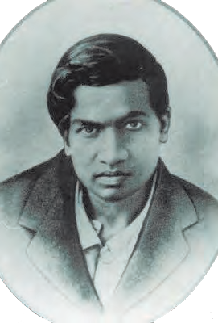

***What did the manuscript contain?***

**Godfrey Harold Hardy (FRS) 1877 - 1947 an**

**English Mathematician**

**manuscript :** a hand written document

**loped off :** moved along with long easy steps

***Why could Hardy not enjoy his game?* altered :** changed

**nagged away :** annoyed by puzzling **epigrammatic :** with a short and witty expression

**clarity :** clearness

**J.E. Littlewood**

**:** An English Mathematician

**contrivances :** appliances, gadgets **after hall :** after

dinner in the dining

hall

One morning early in 1913, Hardy found, among the letters on his breakfast table, a large untidy envelope decorated with Indian stamps. When he opened it, he

found sheets of paper by no means clean, on which, in a non - English script, were line after line of symbols. Hardy glanced at them without enthusiasm.

He felt, more than anything, bored. He glanced at the letter, written in halting English, signed by an unknown Indian, asking him to give an opinion of these mathematical discoveries. The script appeared to consist of theorems, most of them, wild or fantastic looking, one or two already well - known, laid out as though they were original. There were no proofs of any kinds. Hardy was not only bored, but also irritated. It seemed like a curious kind of fraud. He put the **manuscript** aside and went on with his day’s routine.

After lunch he **loped off** for a game of real tennis in the university court. (If it had been summer, he would have walked down to Fenner’s to watch cricket.) In the late afternoon, he strolled back to his rooms. That particular day, though, while the timetable wasn’t **altered**, internally things were not going according to plan. At the back of his mind, getting in the way of his complete pleasure in his game, the Indian manuscript **nagged away**. Wild theorems. Theorems such as he had never seen before, nor imagined. A fraud of genius ? A question was forming itself with **epigrammatic clarity** : is a fraud of genius more probable than an unknown mathematician of genius ? Clearly the answer was no. Back in his rooms in Trinity, he had another look at the script. He sent word to **Littlewood** (probably by messenger, certainly not by telephone, for which, like all mechanical **contrivances** including fountain pens, he had a deep distrust) that they must have a discussion **after hall**.

Before midnight they knew, and knew for certain. The writer of these manuscripts was a man of genius. That was as much as they could judge, that night. It was only later that Hardy decided that Ramanujan was, in terms of natural mathematical genius, in the class

of **Gauss** and **Euler** : but that he could not expect, because of the defects of his education and because he had come on the scene too late in the line of mathematical history, to make contribution on the same scale.



***What did the two English Mathematicians***

***realise by midnight?* Gauss :** German mathematician

**Euler :** Swiss Mathematician

***What were the two drawbacks in***

***Ramanujan’s career?***

**Kapitsa :** Soviet physicist and Nobel Laureate

***What superstition did Ramanujan’s mother believe in?***

**cross the water :**

travel across the sea

/ ocean

**Namakkal :** district in Tamilnadu

**startling :** surprising

***What surprised everyone, one morning?***

**insight :** deep understanding **theological doctrine :**

set of beliefs about God and religion

**pantheistic benevolence** : an attitude of mind to do kind things, born out of many Gods

**Alan St. Aubyn :** Fellow of Trinity **self - indulgence :** doing something for one’s own pleasure and satisfaction

The following day Hardy went into action. Ramanujan must be brought to England, Hardy decided. Money was not a major problem. Trinity had usually been good at supporting unorthodox talent (the college had been the same for **Kapitsa** a few years later). Once Hardy was determined, no human agency could have stopped Ramanujan, but they needed certain amount of help from a superhuman one.

Ramanujan turned out to be a poor clerk in Madras (Chennai), living with his wife on twenty pounds a year. He was usually strict about his religious observances, with a mother who was even stricter. It seemed impossible that he could break the ban and **cross the water**. Fortunately his mother had the highest respect for the goddess of **Namakkal**. One morning Ramanujan’s mother made a **startling** announcement. She had a dream the previous night, in which she saw her son seated in a big hall among a group of Europeans and the goddess of Namakkal had commanded her not to stand in the way of her son fulfilling his life’s purpose. This, say Ramanujan’s Indian biographers, was a very agreeable surprise to all concerned.

In 1914, Ramanujan arrived in England. So far as Hardy could detect (though in this respect I should not trust his **insight** far) Ramanujan, despite the difficulties of breaking the caste laws, did not believe much in **theological doctrine**, except for a vague **pantheistic benevolence**, any more than Hardy did himself. But he did certainly believe in ritual. When Trinity put him up in college within four years he became a fellow. There was no ‘‘**Alan St. Aubyn**” **self - indulgence** for him at all. Hardy used to find him ritually changed into his pyjamas, cooking vegetables rather miserably in a frying pan in his own room.

Their association was a strangely touching one. Hardy did not forget that he was in the presence of a genius, but genius that was, even in mathematics, almost untrained. Ramanujan had not been able to enter Madras (Chennai) University because he could not matriculate

in English. According to Hardy’s report, he was always **amiable** and good - natured, but no doubt he sometimes found Hardy’s conversation outside mathematics more than a little **baffling**. He seems to have listened with a patient smile on his good, friendly, homely face. Even inside mathematics they had to **come to terms with** the difference in their education. Ramanujan was self - taught : he knew nothing of the modern **rigour**, in a sense he didn’t know what a proof was. In an uncharacteristically **sentimental** moment, Hardy once wrote that if he had been better educated, he would have been less ‘Ramanujan’. Coming back to his **ironic** senses, Hardy later corrected himself and said that the statement was nonsense. If Ramanujan had been better educated, he would have been even more wonderful than he was. In fact, Hardy was obliged to teach him some formal mathematics as though Ramanujan had been a scholarship candidate at Winchester. Hardy said that this was the most singular experience of his life . What did modern mathematics look like to someone who had the deepest insight, but who had literally never heard of most of it ?



**amiable :** pleasant and friendly

**baffling :** strange and difficult

**come to terms with :**

accept gradually

**rigour :** harsh, difficult condition or concepts

**sentimental :** full of emotions

**ironic :** opposite of what is expressed

***What did Hardy have to teach Ramanujan?***

***Why does he call it an unusual experience?***

**a Fellow :** an award, title and honour

given by the Royal Society (England)

**conveyance :** (here) a vehicle

***Can you work out the sum of cubes in two different ways which equals 1729?***

***What is exceptional about the number 1729?***

It is good to remember that England gave Ramanujan such honours as were possible. The Royal Society elected him **a Fellow** at the age of thirty (which, even for a mathematician, is very young). Trinity also elected him a Fellow in the same year. He was the first Indian to be given either of these distinctions. He was amiably grateful. But he soon became ill.

Hardy used to visit him, as he lay dying in hospital at Putney. It was on one of those visits that there happened the incident of the taxi - cab number. Hardy had gone out to Putney by taxi as usual, his chosen mehod of **conveyance**. He went into the room where Ramanujan was lying. Hardy, always clumsy about introducing a conversation, said, probably without a greeting and certainly as his first remark : “The number of my taxi cab was 1729. It seemed to me rather a dull number.” To which Ramanujan replied : “No, Hardy !

*It is a very interesting number : It is the smallest number expressible as the sum of two cubes in two different ways”.*

It was difficult, in war - time, to move Ramanujan to a kinder climate. He died of tuberculosis, back in

Madras (Chennai), two years after **the war**. As Hardy wrote in the *Apology*, his roll - call of mathematicians



**the war :** World War I (1914-18)

**Galois :** French mathematician

**Abel :** Norwegian mathematician

: ‘**Galois** died at twenty - one. **Abel** at twenty - seven, Ramanujan at thirty - three, **Riemann** at forty. I do not know an instance of a major mathematical advance **initiated** by a man past fifty’.

 **Riemann :** German Mathematician

 **initiated :** started

 ***Name all the famous mathematicians mentioned in this write-up.***



1. **(A) Use the following words / phrases to make sentences of your own.**
   * enthusiasm  lope off  fraud  clarity
   * amiable  come to terms with  conveyance

**(B) The following words can be used as Nouns as well as Verbs.**

(Visit / honour / report / watch / form / surprise.)

**Make pairs of sentences of your own, using them as a Noun in one and as a Verb in the other.**

For example : (i) She gave a smile -Noun.

(ii) Babies smile when they see their mother - Verb.

1. **Say WHY. . . . . .**
2. Ramanujan’s letter bored and irritated Hardy, at first.
3. Hardy invited Littlewood for a discussion.
4. Mother agreed to send Ramanujan to England.
5. Hardy and Ramanujan could not talk freely with each other.
6. Ramanujan had to be hospitalized.
7. Ramanujan found the number 1729 very interesting.
8. **Read the text and enlist the achievements and honours of Ramanujan, received in England.**
9. **Voice - Active and Passive**

The form of a verb shows whether the doer of an action is in the Subject (Active voice) or the Subject has an action done to it (Passive voice).

For example : The thief stole the jewels. (Active voice).

The jewels were stolen by the thief. (Passive voice)

**Note :** While changing from the Active to the Passive voice, the verb form includes be + past participle.

In a sentence, when the doer of an action is significant, we use the Active voice. In the Passive voice the doer of an action may not be mentioned.

For example : The thief was caught. (*by the police*)

1. **Underline the verbs in the following sentences and state whether the sentences are in the Active or the Passive voice.**
   1. England gave Ramanujan great honours.
   2. A large untidy envelope was decorated with Indian stamps.
   3. The timetable was not altered.
   4. She saw her son in a big hall.
   5. Hardy corrected his statement.
   6. Ramanujan was brought to England.
2. **Change the voice in the following sentences.**
   1. Hardy taught Ramanujan.
   2. He knew nothing of the modern rigour.
   3. Sheets of paper were found in it, by Hardy.
   4. Hardy was bored by that manuscript.
   5. Trinity supported unorthodox talent.
   6. He could not break the ban.
3. **Identify whether the following are Simple, Complex and Compound sentences.**
4. When he opened it, he found sheets of paper.
5. He glanced at a letter.
6. Hardy was not only bored but he was also irritated.
7. Ramanujan turned out to be a poor clerk.
8. If Ramanujan had been better educated, he would have been even more wonderful than he was.
9. Ramanujan was self-taught : he knew nothing of the modern rigour.
10. **Interview Question.**

**A brilliant student from your school has won a Mathematics Quiz at the National Level.**

**Frame questions to interview him / her when the school felicitates him / her. Follow the steps given below.**

1. Greeting
2. Introduction of the interviewee and achievements
3. 2 or 3 questions about the growing years
4. 4 to 6 questions about the achievements
5. 2 or 3 questions about future plans and prospects
6. Expression of thanks and good wishes
7. **Summary**
   * **Read the first three paragraphs on Page 92. (From......... ‘One morning .............. upto a discussion after hall)**
   * **Re-read the same noting down only the important points.**
   * **Rewrite the important points in your own simple language, in you notebook.**
   * **Make certain that your summary is less than half the length of the original passage.**







# A Battle to Baffle



1. **Form suitable groups and discuss the following.**

You have heard / read stories of Akbar and Birbal, Tenali Raman, Mulla Nasruddin. Recollect and write down the names of those stories.

Pick out those aspects of a story that you find a common in all their stories.

(1) Humour (2) Supernatural events

(3) Wisdom (4) Suspense

(5) Magic (6) Beauty of Nature

(7) Wit (8) Play upon words

(9) Sad end (10) Violence

1. **Read the different types of sentences in Reported Speech and note the differences in the Direct and Indirect forms.**
   1. (a) Direct : The old man said, ‘‘What is the time?
      1. Indirect : The old man asked what the time was.
   2. (a) Direct : Mother said to her, “Are you hungry now?
      1. Indirect : Mother asked her if she was hungry, then.
   3. (a) Direct : Teacher said, ‘‘Be quiet students.’’
      1. Indirect : Teacher ordered the students to be quiet.
   4. (a) Direct : Mother said, ‘‘ How pretty she looks!’’
      1. Indirect : Mother exclaimed with delight that she looked very pretty. You will observe that -
2. The Reporting Verb changes according to the type of sentence in the speech.
3. Change of Tense
4. Change of the word order in the sentence.
5. **Use a dictionary and find the differences in the following terms related to ‘Drama’.**

|  |  |  |  |
| --- | --- | --- | --- |
| (1) A Play | (2) One-act Play | (3) Skit | (4) Mime |
| (5) Farce | (6) Opera | (7) Tragedy | (8) Comedy |

# A Battle to Baffle



**scriptures :** sacred writings

**renown :** fame

***What announcement unnerved the Courtiers and Pundits?***

**defiance :** (*here*) a bold challenge

## A Skit

***Characters :***

***Tenali Raman :*** *a witty poet - jester in the court of Emperor Krishnadevaraya*

***Krishnadevaraya :*** *Emperor of Vijayanagar Empire (1509- 1529)*

***Pundit Shahane :*** *A highly learned visiting scholar*

***Mantriji :*** *The Chief Minister*

*8 to 10 other courtiers / ministers / scholars*

***Scene***

*The Court room of Krishnadevaraya*

*(The Emperor is seated on his throne Courtiers / scholars / ministers are seated in two rows facing one another and discussing softly.)*

**Mantriji :** *(Standing up and bowing)* Your Royal Highness, I have some urgent news to convey. May I have your kind permission to announce it?

**Emperor :** Yes Mantriji, you may.

**Mantriji :**Maharaj, a very great scholarly Pundit - Pundit Shahane - has arrived here. He has mastered all our **scriptures** and has won great **renown** all over India.

**Emperor :** He must be a truly brilliant Pundit.

**Mantriji :**Very true, Maharaj! What’s more, Pundit Shahane has come here to challenge all the Pundits in our Kingdom. He is visiting our court tomorrow.

*(All Courtiers, Pundits etc. begin to show nervousness and appear restless.)*

**Emperor :**Hmm! Challenge the knowledge of our Pundits? I’m not sure.

(*Looking at the court.)*

Who all among you can take up this daring test of **defiance**? Come forth.

*(All put their heads down in silence.)*

**Emperor :** (*annoyed)* : Not one of you can face the Pundit?

I am ashamed of all of you. I shall debar you from my court. I have never felt more disgusted. Hmmph! In fact, I shall sentence you all to.....

**First Scholar :** Excuse me, Maharaj! I have a



**voice :** to express something

**exiled :** sent away from the native country

***What suggestion was proposed by the first scholar?***

**predicament :** a difficult, unpleasant situation

**tight corner :** a difficult situation

**diffident :** not confident

**outwit :** prove to be cleverer than

***What was the condition put forth by Tenali Raman?***

**protocol :** an official procedure

suggestion. I humbly seek your permission to **voice** it.

**Emperor :** *(still annoyed)* What is it? It had better be a good one or you shall be the first one to be **exiled** from Vijayanagar.

**First Scholar :** Thank you, Your Majesty! I am

confident. Let us send for Tenali Raman. He will certainly find a solution to this **predicament**.

**Second Scholar : (***Standing up***)** That’s an excellent idea.

Let us call Tenali Raman. He shall certainly pull us out of this **tight corner**.

**Emperor :** Summon Tenali Raman at once.

*(A guard leaves and fetches Tenali Raman.)*

*(Enter - Tenali Raman bowing to the*

*Emperor.)*

**Tenali Raman :** *(bowing)* I am at your service, Your

Highness. Your wish is my command.

**Emperor :** Tomorrow, Pundit Shahane, a most well

- read, well - known scholar is coming to our court to challenge our Pundits. All of them here are **diffident** of taking him up. They have recommended you to **outwit** the challenger. Will you accept it?

**Tenali Raman :** Most certainly, Your Majesty. Let me

assure you that I shall not let you down. But I have a small request. When Pundit Shahane arrives tomorrow, all must accept me and honour me as the Chief Pundit, for one day.

*(All agree and nod their heads.)*

**Mantriji :** We certainly will. And I shall see to it

that you are brought in with honours.

**Emperor :** Court dismissed!

*(All exit after the emperor does.) (Next Day - Courtiers, etc are seated.*

*Emperor’s arrival is announced. As per*

***protocol*** *all stand up and bow as the Emperor procedes and takes up his place.)*

**Emperor :** Be seated!

*(All sit)*



**benign :** kind and gentle

**revered :** respected

***How did Mantriji introduce Pundit Shahane?***

**acknowledgement :**

acceptance

**palanquin :** an ancient box-like structure to transport one person and carried by four to six people with the help of two long poles

***How did Tenali Raman make his entry to Emperor’s court?***

**Taken aback :**

shocked

***What scripture did Tenali Raman wish to debate upon?***

**Mantriji :** With your **benign** permission, you Roy-

al Highness, may I call the great Pundit Shahane and Pundit Tenali Raman?

**Emperor :** Yes, let them be brought forth at once.

(*Guards hurry out. Enters Pundit Shahane, escorted by two soldiers.)*

**Mantriji :** Your Highness, this is Pundit Shahane -

the most **revered** and honoured master scholar of our ancient scriptures. The Pride of India.

*(Pundit Shahane gives a slight bow to the Emperor. Emperor nods in*

***acknowledgement*** *and gestures him to be seated.)*

**Mantriji :** And now may I announce the greatest

of great scholars in Vijayanagar, the Chief Pundit Tenali Raman.

*(Tenali Raman enters, carried on a*

***palanquin****. Gets off, bows to the Emperor,*

*then to Pundit Shahane.*

*Two Pundits follow carrying a huge bundle in silken cloth. They place it next to Tenali Raman.)*

**Emperor :** All of you, be seated, let the Pundits begin the debate.

**Tenali Raman :** *(Placing his hand on the bundle next to him*

*and twisting his moustache with the other)*

Let us begin by discussing the merits of ‘tila- kashta - mahisha - bandhana’

**Pundit Shahane :** *(****Taken aback****)* Wh..........wh. What

was that?

**Tenali Raman :** *(loudly)* Let us debate on the virtues of

the scripture ‘tila kashta - mahisha

- bandhana’

**Pundit Shahane :** *(Stands up, wondering. Moves forward,*

*talks to himself)*

I have read thousands of scholarly works in Sanskrit. But I’ve never even heard of what was that

name tila. . . . . . . . . bandhana . . . . . . something like that. How can I discuss its merits?

*(Pundit Shahane walks up and down in deep thought. The onlookers give sly smiles. Finally Pundit Shahane throws up his hands.)*



***Why was Pundit Shahane defeated?***

**concede :** admit, confess

**coarse :** rough

***What explanation did Tenali Raman give about the***

***name of the strange scripture?***

***How did the emperor and courtiers react?***

**Pundit Shahane :** I give up! A thousand apologies, Your

Highness. I have not read the scripture that Tenali Raman mentions. I **concede** defeat. Tenali Raman is the greatest of all scholars.

*(Bows and exits) (Emperor looking at Tenali Raman)*

**Emperor :** I am proud of you and grateful for

saving the reputation and honour of our great empire. Let me reward you.

**Tenali Raman :** *(Smiling and bowing)* Your words of

praise are my greatest reward, your Highness.

**Emperor :** But tell me Raman, to what great work

did you refer?

*(Tenali Raman opens the bundle and removes a bundle of sticks tied with a thick* ***coarse*** *rope.)*

**Tenali Raman :** Maharaj, ‘til’ is sesame ‘Kashta’ is a

stick, so ‘tilakashta’ refers to the sticks or stems of sesame plants, that you

see in my hands. *(Pointing to the rope)* This is a rope used to tie up buffaloes. ‘Mahisha’ means a buffalo, ‘bandhana’ is the rope used to tie up something.

So this is the ‘tila-kashta- mahisha- bandhana.’

**Emperor :** *(laughing loudly)* So the Pundit got scared

when he heard such a complicated name.

*(Laughs again. Everyone joins in the*

*laughter.)*

(Curtain)



1. **Read the following words and use them in sentences of your own.**

Renown, defiance, exiled, predicament, diffident, benign

1. **Read the following phrases and use them in the sentences of your own in proper form.**
   * voice something  a tight corner
   * outwit  concede defeat
2. **Pick out dialogues of Tenali Raman that prove that he had the following qualities.**

(a) Wit and wisdom (b) Self-confidence

(c) Politeness (d) Humility

1. **Answer the following questions in short.**
2. What was Pundit Shahane’s claim as a scholar?
3. Why did Pundit Shahane visit Vijaynagar?
4. What do you learn about Pundits of Vijaynagar?
5. What punishment did the emperor threaten the Pundits with?
6. Why was Tenali Raman summoned to the court?
7. On what condition did Tenali Raman agree to take up the challenge?
8. Why was Tenali Raman taken to the court in a palanquin?
9. How did Tenali Raman outwit Pundit Shahane?
10. What did the bundle in silken cloth contain?
11. Explain the significance of the title.
12. **Fill in the elements that you find in the drama script of ‘A Battle to Baffle.’ Characters :**
    * Background Scene :
    * Crisis :
    * Steps taken to resolve the crisis :
    * Climax :
    * The end :
13. **Do as directed. (Make sure you do not change the meaning and tense of the sentence).**
14. Tenali Raman proved to be wittier than Pundit Shahane.(Rewrite using ‘as witty as’)
15. Pundit Shahane has come here. He wishes to challenge all the Pundits in our Kingdom. (Combine the two sentences using ‘so’. Now combine the same sentence using ‘because’)
16. How can I discuss its merits? ( Make it Assertive)
17. I have not read that scripture. ( Rewrite using ‘unaware’)
18. Your words of praise are my greatest reward. (Begin the sentence with ‘No other )
19. I am proud of you. ( Rewrite using the noun form of the underlined word).
20. The Emperor said, “ But tell me Raman, to what great work did you refer?” (Convert into the Indirect Speech).
21. Tenali Raman was a poet scholar and jester in Vijaynagar in Krishnadevarayas

court. (Punctuate.)

1. Mantriji said Maharaj Pundit Shahanes visit to our court is an open challenge. (Punctuate.)
2. **A past student of your school has cleared his UPSC examination and being an IAS officer, has been appointed the Collector of your district. Write a formal letter to invite him to your school to share the story of his success, at a special function.**
3. **Understand the quotation and expand it in a paragraph format.**

‘***Pride goes on horseback, but returns on foot***’.







इयततञा ५ िी, ८ िी वशष्यिृतती परीक्ञा मञाग्भदवश्भकञा

* मरञाठी, इंग्रजी, उद््भ, विंदी मञाधयमञामधये उपलबध
* सरञािञासञाठी विविध प्शन प्कञारञांचञा समञािेश
* घटकवनिञाय प्शनञांचञा समञािेश
* नमुनयञादञाखल उदञािरणञांचे सपष्ीकरण

पुस्तक मागणीसाठी [www.ebalbharati.in,](http://www.ebalbharati.in/) [www.balbharati.in](http://www.balbharati.in/) संके्त स्थळावर भेट द्ा.

साहित्य पाठ्यपुस्तक मंडळाच्या हिभागी्य भांडारांमध्यये हिक्रीसाठी उपलब्ध आिये.

**ebalbharati**

विरञागीय रञांडञारे संपक्क क्रमञांक : पुणे -  २५६५९४६५, कोलिञापूर-  २४६८५७६, मुंबई (गोरेगञाि)

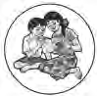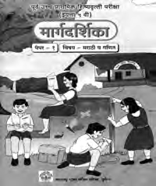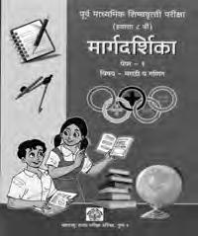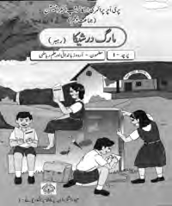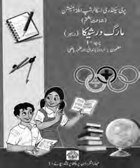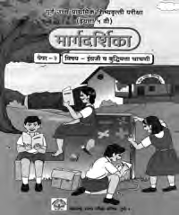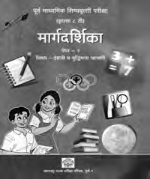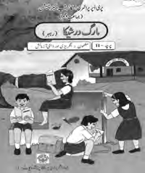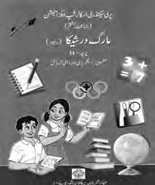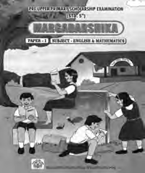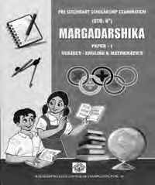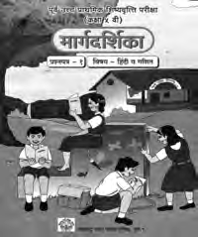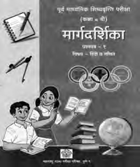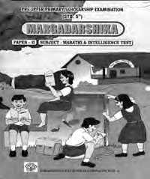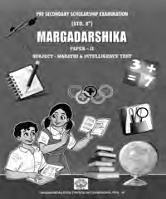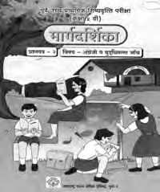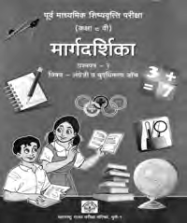

-  २८७७१८४२, पनिेल -  २७४६२६४६५, नञावशक -  २३९१५११, औरंगञाबञाद - 

२३३२१७१, नञागपूर -  २५४७७१६/२५२३०७८, लञातूर -  २२०९३०, अमरञािती -  २५३०९६५

